IMPLEMENTATION OF AN ALGORITHMIC APPROACH FOR DETECTING EPILEPSY.
Balamurugan Balusamy ¹ Daisy v k ²
Faculty Lecturer
School of Computing Sciences, Ranipettai Engineering College
VIT University Vellore,
India India
kadavulai@gmail.com daisy.mtech@yahoo.co.in

Abstract: Electroencephalogram (EEG) is a tool for measuring electrical activity of the brain. Monitoring EEG has proven to be an effective method for diagnosing many neurological illness and diseases such as epilepsy, tumor, encephalitis, and sleep disorders. It is difficult to find the fine variations in the signal because the signals are too lengthy. So fully automated systems to overcome the above problems are proposed. This paper proposes a neural network based automatic detection of sleep stages and epilepsy. The main objective of the system is to classify brain signals for identifying diseases. The proposed system goes through storage of signals, preprocessing, segmentation, and feature extraction and classification stages.

Index terms: Artificial neural network (ANN), Back Propagation Network (BPN), Electroencephalograph (EEG), Independent Component analysis (ICA), Non-Linear Energy Operator (NLEO), Discrete Wavelet Transform (DWT).

1. Introduction
This paper proposes a novel method for the classification of sleep disorders and epilepsy. Sleep disorders now a days gain much more attention in the research area because it is the basic symptoms of some major diseases such as cancer and psychiatric problems [1]. After pain, sleep disorder is the second most indicator of illness. Sleep is the basic symptoms of some major diseases such as cancer and Psychiatry. So sleep disorder should be detected earlier and thereby give better treatments for the patients. Epilepsy is the abnormal activity of the brain. It is noticed that one in hundred of the populations are the victims of this diseases. Some times Convolutions and unconscious are the symptoms of epilepsy. All the above two diseases are diagnosed by the encephalograph (EEG).

The electrical nature of the human nervous system has been recognized for more than a century. It is well known that the variation of the surface potential distribution on the scalp reflects functional activities emerging from the underlying brain. This surface potential variation can be recorded by affixing an array of electrodes to the scalp,
and measuring the voltage between pairs of these electrodes, which are then filtered, amplified, and recorded. The resulting data is called the EEG [13]. The EEG has the small signal amplitude in the range of microvolts (μV). EEG frequency band are normally classified into five categories. The meaning of these different frequencies is not completely known. They are alpha, beta, theta, delta and gamma. Alpha waves are rhythmic waves occurring at a frequency between 8 and 13 hertz. These waves are found in the normal persons when they are awake in a quiet, resting state [1]. When the subject is asleep, the alpha waves disappear completely. Beta waves normally occur in the frequency range of 14 to 30 hertz. These waves can be divided into two type’s beta 1 waves and beta 2 waves. Beta 1 is elicited by the mental activity and the other is inhibited by it. Theta waves have frequencies between 4 and 7 hertz. These waves occur during emotional stress, particularly during periods of disappointment and frustration. Delta waves occur only once every 2 or 3 seconds. They occur in deep sleep, in infants and in serious organic brain diseases. Gamma waves consist of low-amplitude, high-frequency waves resulting from attention or sensory stimulation. All these waves have their own particular shapes in the signals and if any kind of diseases occur then the normal wave’s shapes have changed. Theta and delta waves are normally used to diagnosis the sleep disorders. Sometimes the signal shape of epilepsy and one kind of sleep disorder say narcolepsy may overlap. Visual inspection of EEG signals is very time consuming and very laborious work. So the EEG signal parameters extracted and analyzed using computers, are highly useful in diagnostics. The data can be as many as 128 channels but normally 20 channels are used and recordings typically last for 30 to 60 minutes
of time domain information, with a bandwidth between 0.1 to 150Hz, which is displayed digitally on a computer screen[15].
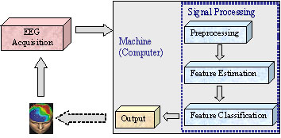

Figure 1: Implicated Processes

2. Methods and Materials

The brain analysis and classification follows a specific method custom designed for the identification of brain diseases. Figure 2: shows the block diagram of the proposed neural network [2] based automated brain signal analysis system.

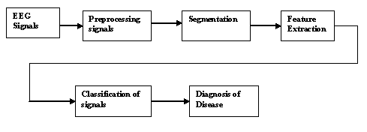

Figure 2: Block diagram of the proposed system

A. Signal acquisition and EEG Database

EEG acquisition collects these underlying electrical patterns from the scalp, and digitalizes them for computer storage. In our experiments, we have used the10-20 System of Electrode Placement, which is based on the relationship between the location of an electrode and the underlying area of cerebral cortex (the "10" and "20" refer to the 10% or 20% interelectrode distance). These signals include normal and abnormal signals of EEG. Divide them and name them as set A and set B. Set A contain normal signals. B contains abnormal signals such as sleep disorders and epileptic signals. In the present study we classify them as two datasets.

B. Preprocessing

Once the signals are acquired, it is necessary to clean them. Usually EEG signals are contaminated [5]. These contaminations may leads to misdiagnosis of diseases. So before analyzing the signals, it should be artifact free [6]. To remove the artifacts there are various methods. However, environments with large, low-frequency electromagnetic fields can cause a significant interference to EEG recordings. The second limitation is the activity of muscles in the head region (e.g. chewing, speaking, etc). The electrical activities of these muscles have, usually, much large amplitude then the EEG. With some effort in quality
control and artifact processing the disadvantages can be compensated [14]. The best method for EEG signal preprocessing is Independent Component Analysis (ICA) [10]. ICA is a method for finding underlying factors or components from multivariate statistical data. ICA outperforms the classical principal component analysis (PCA) in many applications, in particular, it has been applied for the extraction of ocular artifacts from the EEG, where principal PCA could not separate eye artifacts from brain signals, especially when they have comparable amplitudes [13]. Principal component analysis (PCA) is another method that is available, when compared with ICA for the chosen application went short of effectiveness and efficiency [16].
Let s (t) is the signals generated. These signals are linearly combined through a memory less channel, mathematically described by the mixing matrix A. A has M rows, N columns, and xi (t) (I = 1 …M) are the signals observed at the channel output.

The mixing model is described by the following equation

X (t) =A.S (t)…………………… (1)

Where s (t) and x (t) are the source and mixture signal vectors, respectively.

After mixing, the preprocessing of ICA involves the following steps. Centering, whitening and rotation. Centering make the signals centered in zero. The main purpose of centering is to make the zero mean. Centering is achieved by simply subtracting the mean of signal from each reading of that signal.

X = x-E (x)………………………... (2)

The next step is to whiten or sphere the data. This means that remove any correlations in the data [7]. Whitening is achieved by the eigen-value decomposition of the covariance matrix. Taking the covariance between every pair of signals can form a covariance matrix. This matrix will be square and symmetric.

COV (X) = E (XXT)

Perform eigen-value decomposition on the covariance matrix and then transform the data so the covariance matrix of the transformed data is equal to the identity. This procedure is called sphereing or whitening.

V = ED^{-1/2}E^{T}……………………... (3)

(Eigen value decomposition of covariance matrix E {XX ^{T}} = EDE ^{T} and D-1/2 = diag (d1-1/2, d2-1/ 2 … dn-1/2)]

Now rotation can be done by the inverse of whitening operation on the mixing matrix A.

S = Ã⁻¹Z…………………………… (4)

Where Z = VX.
The disadvantages of EEG are that the signal to noise ratio is poor; and it is necessary to deal with large subject-specific, inter- and intra-trial variability; hence, sophisticated data analysis has to be completed.

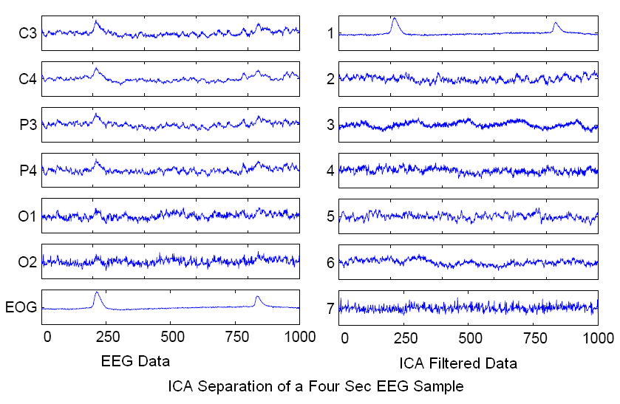
Figure 3: ICA separation of a four sec EEG Sample.

C. Segmentation

In order to analyze non-stationary signals, it is sometimes easier to segment signals into pseudo-stationary segments. Using adaptive segmentation algorithms[4], the non-stationary signals can be broken down into segments that are pseudo-stationary, and analyzed or processed separately. Signal segmentation is based on energy and frequency of signal and the signal has to be divided according to its characteristics. The main purpose segmentation is to find the edge and the energy of the signal. Among the various segmentation algorithm’s NLEO is the best one.
A segmentation algorithm involving a non-linear energy operator (NLEO) is defined as follows.

E{ Ψ [x(n)]}= E[ x(n-1) x(n-2)-x(n)x(n-3) ]...................(5)
Where x (n) is the input EEG signal at current time n and Ψ [(x (n)] = x (n -1) x (n-2) -x (n)-x (n-3) is the nonlinear energy operator. Using NLEO, we can calculate the localized energy, and segment boundary. To detect a sudden change in the NLEO, a variable used for segmentation criteria is defined as follows.

n n+N
Gnleo (n) = ∑ Ψ (m) − ∑ Ψ (m).. (6) m = n−N+1 m = n+1

Where 2N is the window size. Gnleo (n) reaches a peak when the Ψ (m) is discontinuous. The boundaries can be detected by the peaks of Gnleo (n). According to the windowing and thresholding equation the significant level can be obtained. The threshold equation can be defined as

T (n) = max [Gnleo (n – L/2: n+L/2)], L window length (7)

Where Gnleo (n) is the energy change in the window obtained by using a moving window with length 2N at center n, and T (n) is the threshold value obtained by using another moving window with length L. G (n) represents the significant energy change after thresholding.

D. Feature extraction

After segmentation features should be extracted. Different features are suited for different diseases. The proposed system uses discrete wavelet transform (DWT) for sleep disorders and spectral entropy for epilepsy. Spectral entropy quantifies the spectral complexity of the time series. Power spectral density is defined as

P (ω) = I / N (|X (ω)|)……….. ………..(8)
Where X (ω) represents fast Fourier transform of the signal. The normalization of equation (8) gives the spectral entropy and is defined as

H (ω) = ― ∑ pω log pω…………………………..(9)

Discrete wavelet transform (DWT) is suited to non-stationary signals and performs a multiresolution analysis of a signal. It builds on the concept of scales. The following features were found to be suitable for epilepsy detection[3].
Zero crossing
Extrema

E. Neural network Classifier

Artificial Neural Networks (ANN) is considered to be good classifier due to their inherent features such as adaptive learning, robustness, self organization, and generalization capability. ANN’s are particularly useful for complex pattern recognition and classification tasks where enough data are available for training and where the simpler classification algorithms fail. In neural network, designing the architecture and network training are the main issues. If training is insufficient, then network will not learn properly. If excessive training of network is unable to generalize the training database. For each type of EEG signals, a corresponding output class is associated. In order to make neural network training [2] more efficient, the input features were normalized so that they fall in the range [0, 1]. Since the number of output class is 2, the ANN with one output is sufficient to produce a code for each class. The output are represented by
[0] = Normal sleep states or normal states.
[1] = Abnormal that is sleep disorders or epileptic seizure.
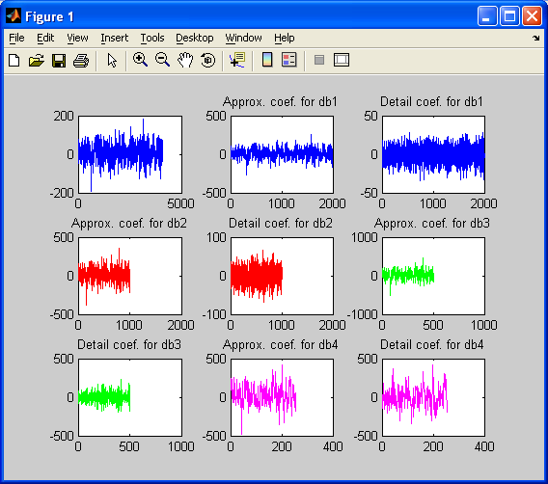

Figure 4: Co-efficient Analysis
The proposed system makes use of BPN. It is a multilayer, feed forward and supervised learning model. Back propagation is the best-known training algorithm for neural networks and still one of the most useful. It has lower memory requirements than most algorithms and usually reaches an acceptable error level quite quickly, although it can be very slow to converge properly on an error minimum.

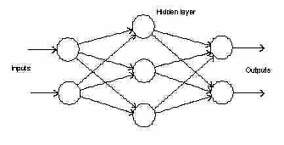

Figure 5: Architecture of back propagation network

F. Validation
The performance of BPN are evaluated by using the two parameters namely sensitivity (SE) and specificity (SP) which are defined as follows.

SE = TNcp/TNcp × 100… (10)

Where TNCP represents the total number of correctly detected positive patterns and TNAP represents the total number of actual positive patterns. A positive pattern indicates a detected seizure.

SP = TN _{CN} /TN _{CN} ×100………. (11)

Where TN_{CN} represents the total number of correctly detected negative patterns and TN_{AN} represents the total number of actual negative patterns. A negative pattern indicates a detected non seizure
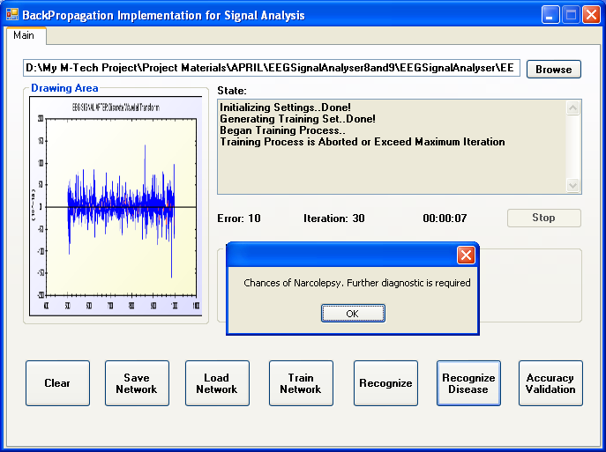

Figure 6: Final yield

CONCLUSION

The Work proposes an algorithm which will prove useful in biomedical signal processing where a specific underlying signal requires to be extracted from the possibly noisy multi-channel recordings. It is clear that the method is suitable for the extraction of independent components from the measured EEG. The algorithm worked efficiently in extracting sleep spindle as well as epilepsy seizures which were distributed throughout the measurement channels. We hope that this system will be useful in the department of neurology and will serve mankind. Recent advances in computer hardware and signal processing have made possible the use of EEG signals or “brain waves” for communication between humans and computers [13] and the same work can further be extended towards the domain also.

References

1. Jakob stastny, Pavel Sovka, Andrej Stancak, ‘EEG Signal Classification: Introduction to the Problem’ Conference on Radio Engineering SEP 2003.

2. [AKAE-2005] ‘Neural Network Classification of EEG Signals by Using AR with MLE Preprocessing For Epileptic Seizure Detection’, pp. 57-70, 2005.

3. [SES-2007] ‘Approximate Entropy-Based Epileptic EEG Detection Using Artificial Neural Networks’, IEEE transaction information technology in biomedicine MAY 2007.

4. [LW-2006] ‘Time-frequency evaluation of segmentation methods for neonatal EEG signals, ‘IEEE EMBS Annual International Conference ‘2006.

5. [GGAD-1995] ‘A new EEG Signal Processing Technique for Discrimination of Eyes Close and Eyes Open’ Proceedings RC IEEE-EMBS & 14th BMESI – 1995.

6. [PGBM-2006] ‘Removing Ocular Artifacts from EEG signals using Adaptive Filtering and ARMAX Modeling’ PWASET Volume 11 Feb 2006

7. [MS-2006] ‘Assessment of Preprocessing of Classifiers used in the P300 speller paradigm’ International Conference on BCI Sep 2006.

8. [UBSL-2004] ‘Independent Component Analysis Applied in Biomedical Signal Processing’ Measurement Science Review, Volume 4, 2004.

9. J. Jamei, M.B. shamsolahi ‘Adaptive Zero-Tracking of EEG Signals for Detecting Epileptic Patients’.

10. C.J.James, O.Gibson ‘Electromagnetic Brain signal analysis using Constrained ICA’

11. [IHWH-2005]’ Biopattern Analysis and Subject-Specific Diagnosis and Care of Dementia’ Proceedings of the 2005 IEEE Engineering in Medicine and Biology’.

12. [HBL-2004] ‘Mutual Information entropy Research on Dementia EEG Signals’, IEEE transaction in biomedicine.
13. [2002] Touradj Ebrahimi. ‘EEG Signal Classification for Brain
Computer Interface Applications’. Ecole Polytechnique Federale De Lausanne.
14. Alois Schlög, Mel Slater, Gert Pfurtscheller.’ Presence research and EEG’.
15. DS Holder, RH Bayford, J Fritschy O Gilad, H Kaube and CD Binnie.’ Development of generic software for analysis, archiving & Internet dissemination of
brain and systems physiological data.
16. [Fall 2003] James N. Knight
‘Signal Fraction Analysis and Artifact Removal in EEG’.

