Automatic Classification Of White Blood Cell Based on Fuzzy
Cellular Neural Network
S.JONE ROSY M.E,Mrs.N.PADMA PRIYA M.E
Lecturer, PANIMALAR ENGINEERING COLLEGE,Chennai.
sjonerosy@gmail.com

Abstract—White blood cell detection is one of the most basic and key steps in the automatic recognition system of white blood cells in microscopic blood images. Its accuracy and stability greatly affect the operating speed and recognition accuracy of the whole system. But there are only a few methods available for cell detection or segmentation due to the complexity of the microscopic images. This paper focuses on this issue. Based on the detailed analysis of the existing two methods—threshold segmentation followed by mathematical morphology (TSMM), and the fuzzy logic method—a new detection algorithm (NDA) based on fuzzy cellular neural networks is proposed. NDA combines the advantages of TSMM and the fuzzy logic method, and overcomes their drawbacks.With NDA, we can detect almost all white blood cells, and the contour of each detected cell is nearly complete. Its adaptability is strong and the running speed is expected to be comparatively high due to the easy hardware implementation of FCN. Experimental results show good performance.
I. INTRODUCTION
HEMANALYSIS is a critical examination. It provides much valuable information for the quantitative analysis ,life study, and early diagnoses of various diseases. The hematologist requires two types of blood count for diagnosis and screening. One is called the complete blood count (CBC) and the other is called the differential blood count (DBC). CBC can be done by instruments called cytometers and can successfully be performed automatically. On the other hand, DBC ismore reliable, but currently is a manual procedure done by hematology experts using a microscope
The process of an automatic differential blood counter system may require four steps: acquisition, detection, feature extraction, and classification.
Automatic white blood cell detection is very difficult. First, besides white blood cells, there exist red blood cells, platelets, and other objects mixing in the microscopic blood images. To distinguish one element from others becomes very difficult when occlusion, staining reagent, or illumination are inconsistent.Second, the maturity classes of the white blood cells actually represent a continuum, and cells frequently overlap each other, so there is fairly wide variation of size and shape of nuclei and cytoplasm regions within given cell classes. Such difficulties make white blood cell detection a hard and challenging problem..Regarding the detection step, a few methods have been pesented . Threshold segmentation followed by mathematical morphology (TSMM) ,Fuzzy Logic method, and Fuzzy Cellular Neural Network Since there are certain disadvantages in TSMM and Fuzzy Logic method Fuzzy Cellular Neural Network is proposed in this paper. .
Besides threshold segmentation, mathematical morphology and fuzzy logic, neural networks have been widely and successfully used in medical image analysis including image segmentation , because of their good performance in classification and regression. Among them, the topology peculiar to cellular neural networks (CNN) is very close to the human’s visual mechanism. Moreover, the successful development of VLSI makes it possible that CNN satisfies the requirements in real-time image processing. Thus, CNN has become a popular model for solving various image processing problems. Its wide applications span from preprocessing ship images to the recognition of ancient Chinese characters.
FCNN is the combination of fuzzy logic and neural networks. It inherits both the capability of fuzzy logic to cope with uncertainty in image, and the capability of CNN to solve different kinds of image processing problems . Unlike the traditional CNN structures , FCNN has inherent connections with mathematical morphology.
II. NDA BASED ON FUZZY CELLULAR NEURAL NETWORKS
- Fuzzy Cellular Neural Networks
4×4 FCNN is shown in Fig. 1. Similar to CNN, CNN is a locally connected network. The output of a neuron is connected to the inputs of every neuron in its r × r neighborhood, and similarly the inputs of a neuron are only connected to the outputs of every neuron in its r × r neighborhood. It is apparent that feedback (but not recurrent) connections will be presented.
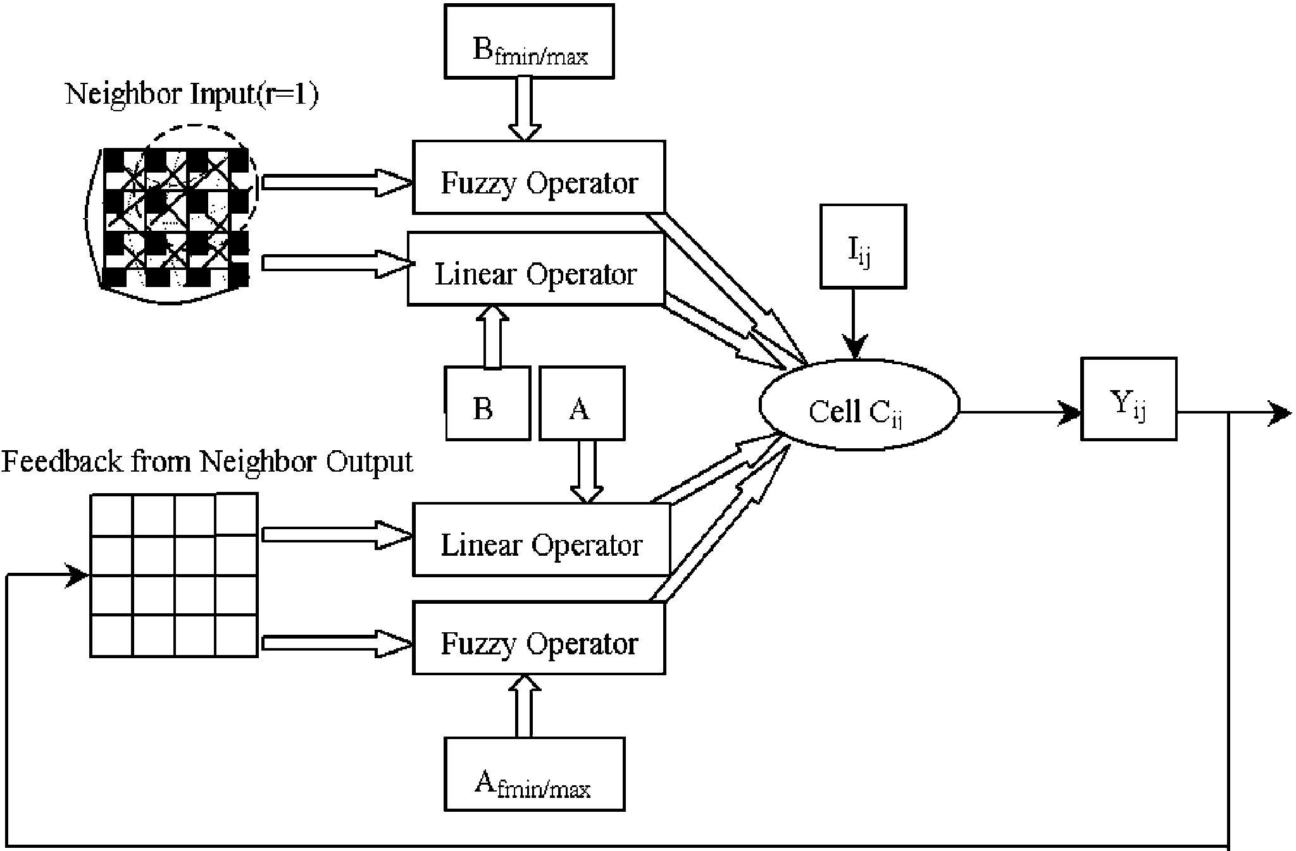

Fig1:structure of FCNN
B. Details of FCNN
The detailed procedures of the new detection algorithm are as follows.
P1) Use the pyramidal method to compress the R-image,G-image, and B-image, respectively.
P2) Transform the color image from (R, G, B) to the hue element of HLS [16].Suppose (r, g, b) represents a pixel in a RGB image r, g, b ∈ [0, 1, . . . , 255], v’ = max(r, g, b), u’ =min(r, g, b)
R’= $\frac{g−b}{v−u}$, g’ =$\frac{b−r}{v−u'}$, b’= $\frac{r−g}{v−u}$
H’ =
h = 60h’.
P3) Normalize the hue image with the formula
H = H’ − h,H −h > 0
H − h + 240,H − h ≤ 0
where h is the peak value in the histogram of the hue image.
P4) Linearly contrast the hue image with the formula g(i, j) =(y2 − y1/x2 − x1)[f(i, j) − x1] + y1, where x1, x2 are the minimum and maximum values in the original image, and y1, y2 are the minimum and maximum values in thecontrasted image. f(i, j) represents the original value of
the point (i, j), and g(i, j)is the value of the point after contrast.
P5) Obtain the subset of white blood cell region by FCNN
with the following parameters:
A=$\begin{aligned}\left[\text{1/9 1/9 1/9} | \right]\left[\text{1/9 1/9 1/9} | \right]\left[\text{1/9 1/9 1/9} | \right]\left[ | \right]\left[ | \right] \\ \end{aligned}$,B=0
Afmin=undefined,Afmax=undefined
Bfmin = undefinedBfmax = 0, Rx = 1,
I = 0, u= X, x0 = random, y= Y.
P6) Morphological gray reconstruction based on FCNN [19],regarding the subset of a white blood cell as the mark image and the hue image as the original image.
P7) Restore the original color information inside the white blood cell regions.
An important feature of NDA is the adoption of FCNN. However, restricted to the objective conditions, FCNN is simulated by software in our experiments. In order to save operation time,we compress the image to be settled at first. If the FCNN chip is available, P1 can be skipped.It should be noted that FCNN itself is applicable not only to gray images, but also to color images. In order to deal with a color image, three FCNNs should be constructed for the R image , G-image, and B-image, respectively. The three component FCNNs can perform in parallel by hardware. But, in software, that will take time. Considering the requirement of real-time processing, we need to transform color images into gray ones (P2) and do some necessary normalization/contrast (P3, P4) before feeding the images into the FCNN. Generally speaking, a gray image needs less processing time and smaller storage capacity than a color image of the same size, whereas the information in a color image is richer than that in a gray one. This means that some useful information may be lost after color conversion unless we can find a proper conversion. After many observations, we find that the hue element of the HLS model has much better consistency with all the microscopic images stained by different reagents under different illumination than the traditional conversion by function D = 0.3R + 0.59G + 0.11B. That is the reason why we use HLS in (P2) rather than the traditional conversion. This procedure gives a good foundation to the following processing procedures and helps NDA break down the application limitation (gray image) of TSMM and the fuzzy logic method
After inspecting the images from P4, we easily find that white blood cells usually show the smaller gray value than red blood cells; and white blood cells are in a round shape because of the nuclei inside, whereas the red blood cells are in ring form because of no nucleus inside . In order to make full use of both the gray information and the structure knowledge,
we use FCNN to obtain the subset of white blood cell region. It is similar to the idea of the fuzzy logic method in Another advantage of adaptive FCNN in P5 is that there is no need for us to set the parameter n by experience, as in TSMM. From the analysis in Section I, the parameter n is very important to TSMM. Suppose an image contains two white blood cells, and one is much larger than the other. If n is too big, the smaller one could possibly be omitted after n erosions and dilations. If n is too small, some red blood cells, platelets, and other objects remain after n erosions and dilations. With adaptive FCNN, we can eliminate these disturbers thoroughly. Even under the
circumstances that the gray value of some red blood cells and cytoplasm are close , where the cytoplasm is in the middle of the image], we can still get the white blood cell regions or subset . With TSMM, it is very hard to obtain as good an effect, where the mask is 3×3 square and the number of erosion/dilation operations is 3. The contour of white blood cells is distorted, which is disadvantageous for the following feature extraction.
Next, we use FCNN once more in P6 to realize the morphological gray reconstruction. The subset of a white blood cell is reconstructed into the whole white blood cell. In other words, this procedure yields the white blood cells with complete contour.Finally, we restore the original image inside the white blood cell regions for the following feature extraction.
From the aforementioned analysis, it is easy to see that NDA has at least three advantages. First, it can detect almost all white blood cells because it makes full use of both the color information and the structure knowledge during the same processing. Second, each detected white blood cell is nearly complete, thanks to the morphological gray reconstruction. Third, NDA has strong adaptability to staining and illumination because of the proper color transformation.
III. CONCLUSION
The methods of white blood cell detection in the automatic recognition systems of microscopic blood images have been addressed in this paper. After carefully analyzing the disadvantages of the existing two methods, we proposed a new detection algorithm, NDA, based on fuzzy cellular neural networks. With this new algorithm, we can detect almost all white blood cells, and each detected cell is nearly complete. Its adaptability is strong and the running speed is comparatively high. Experimental results show that the NDA’s performance is better than the other two methods. However, we need to point out that the results presented here are only the first step in the exploration of automatic recognition systems for white blood cells in microscopic blood images. There are still some open problems waiting for further exploration. For example, how to distinguish nucleus from cytoplasm effectively is a challenging problem. Another problem is how we can further improve the FCNN such that NDA will have better performance. We will investigate these problems in the near future.
IV EXPERIMENTAL RESULT
The image is first preprocessed to remove the noise.The preprocessing can be done using certain filters.Here the Average filter is used.Average filter filters the noise from the input image.Edge detection is the next step which can be performed using laplacian or Gaussian method
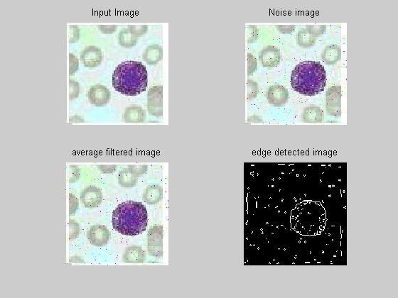
REFERENCES
[1] I. T. Young, “The classification of white blood cells,” IEEE Trans. Bio.Med. Eng, vol. 19, no. 1, pp. 291–298, Jan. 1999.
[2] M. Beksac, M. S. Beksac, V. B. Tipi, H. A. Duru, M. U. Karakas, and A. N. Cakar, “An artificial intelligent diagnostic system on differential recognition of hematopoietic cells from microscopic images,” Cytometry, vol. 30, pp. 145–150, 2004.
[3] H. Harms, H. Aus, M. Haucke, and U. Gunzer, “Segmentation of stained blood cell images measured at high scanning density with high magnification and high numerical aperture optics,” Cytometry, vol. 7, pp.522–531, 2004.
[4] J. Park and J. Keller, “Fuzzy patch label relaxation in bone marrow cell segmentation,” in Proc. IEEE Int. Conf. Syst.,Man, Cybern., Orlando, FL,1997, pp. 1133–1138.
[5] S. S. S. Poon, R. K. Ward, and B. Palcic, “Automated image detection and segmentation in blood smears,” Cytometry, vol. 13, pp.766–774, 1992.
[6] Y. Xiao-min, L. Li-min, and W. Yu, “Automatic classification system for leukocytes in human blood,” Chinese J. Comput., vol. 17, no. 2, pp.130–136, 2004.
[7] P. Sobrevilla, E. Montseny, and J. Keller, “White blood cell detection in bone marrow images,” Fuzzy Information Processing Soc. 18th Int. Conf.North American, New York, Vol. 10–12, Jun. 1999, pp. 403–407.

