INTRUSION DETECTION SYSTEM
AVINAY KUMAR LALL, avinaylall@gmail.com
AMIT KUMAR, zoom2raj@gmail.com
AARUPADAI VEEDU INSTITUTEOF TECHNOLOGY, VINAYAKA MISSION UNIVERSITY , KANCHIPURAM DIST., CHENNAI – 603104

ABSTRACT
In this paper we has discussed about introduction to INTRUSION DETECTION SYSTEM. We are focusing on the security application that identifies suspicious network activity. The idea is to present different kinds of Intrusion Detection Systems and at the same time their advantages and disadvantages. This will enlighten about the Intrusion, detection system, its architecture, its types, prevention with some working example in use. The key idea is to determine the intrusion by inspecting inbound and outbound traffic on a host or network analyzing it and looking for evidence of attempted intrusion. Using its types (HIDS & NIDS) it is described more specifically. With its architecture it is easier to understand the working principle of the detection. We provide an overview on the Development and Implementation of the system. We also give a look on the prevention system and its difference with the detection system. Using the latest experiments and development on two more models (Anomly based & Signature based detection system), we has provided the current preview of intrusion detection. With the help of suitable and frequent examples we tried to make the topic more understandable. Finally we look the real time example (Snort) for the detection and prevention system.

INTRODUCTION
An Intrusion Detection System (IDS) is basically an application or device that identifies suspicious network activities. At first we gave an overview about the different kinds of IDS to be able to address different tactics afterwards. In the last part we include discussion on several programs like Snort.
In advance, we like to give some annotations for terms which we are not explained directly in the topics:
- false positive = an alarm that an attack has taken place whereas this was not the case
- false negative = the IDS does not detect and filter the attack
INTRUSION
(An attempt to compromise a system or network)
It’s like that someone getting in your house without your permission and knowledge.
Intrusions are attempts by malicious individuals to discover and exploit vulnerabilities that may be used to compromise network security. Any suspicious network traffic that falls outside of normal or legitimate traffic patterns may be classified as an Intrusion.
The result of Intrusion can take different forms, including the following:
- Destruction of theft of data
- Denial of service(DoS) to legitimate network users
- Hijacking of system & communication session.

INTRUSION DETECTION SYSTEM (IDS)
An application or device that identifies suspicious network activity
An Intrusion detection system inspects inbound and outbound traffic on a host or network analyzing it and looking for evidence of attempted intrusion.
Most IOD products are passive system whose job is merely to detect evidence of intrusion and alert administrators to possibly attack on their network. Recently vendors have begun to develop IDS products that can perform actions to protect against attacks when they are detected. Such actions might include closing certain ports or blocking certain Internet protocol (IP) address. A reactive IDS product is sometimes called an Intrusion Prevention System (IPS). Some IDS products combine host and network based detection and are sometime called Hybrid Systems.
An Intrusion Detection System (abbreviated as IDS) is a defense system, which detects hostile activities in a network. The key is then to detect and possibly prevent activities that may compromise system security, or a hacking attempt in progress including reconnaissance/data collection phases that involve for example, port scans. One key feature of intrusion detection systems is their ability to provide a view of unusual activity and issue alerts notifying administrators and/or block a suspected connection. According to Amoroso, intrusion detection is a process of identifying and responding to malicious activity targeted at computing and networking resources". In addition, IDS tools are capable of distinguishing between insider attacks originating from inside the organization (coming from own employees or customers) and external ones (attacks and the thread posed by hackers).

IDS Architecture
An intrusion detection systems always has its core element - a sensor (an analysis engine) that is responsible for detecting intrusions. This sensor contains decision-making mechanisms regarding intrusions. Sensors receive raw data from three major information sources : own IDS knowledge base, syslog and audit trails. The syslog may include, for example, configuration of file system, user authorizations etc. This information creates the basis for a further decision-making process.
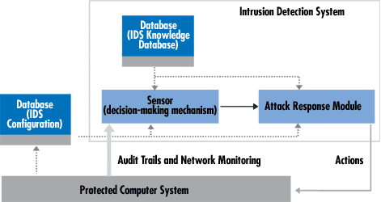
A sample IDS. The arrow width is proportional to the amount of information flowing between system components
The sensor is integrated with the component responsible for data collection (Fig.4) — an event generator. The collection manner is determined by the event generator policy that defines the filtering mode of event notification information. The event generator (operating system, network, application) produces a policy-consistent set of events that may be a log (or audit) of system events, or network packets. This, set along with the policy information can be stored either in the protected system or outside. In certain cases, no data storage is employed for example, when event data streams are transferred directly to the analyzer. This concerns the network packets in particular.
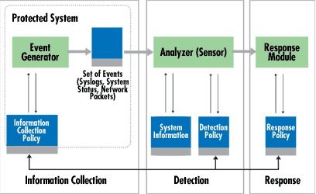
IDS components
The role of the sensor is to filter information and discard any irrelevant data obtained from the event set associated with the protected system, thereby detecting suspicious activities. The analyzer uses the detection policy database for this purpose. The latter comprises the following elements: attack signatures, normal behavior profiles, necessary parameters (for example, thresholds). In addition, the database holds IDS configuration parameters, including modes of communication with the response module. The sensor also has its own database containing the dynamic history of potential complex intrusions (composed from multiple actions).
Intrusion detection systems can be arranged as either centralized (for example, physically integrated within a firewall) or distributed. A distributed IDS consists of multiple Intrusion Detection Systems (IDS) over a large network, all of which communicate with each other. More sophisticated systems follow an agent structure principle where small autonomous modules are organized on a per-host basis across the protected network . The role of the agent is to monitor and filter all activities within the protected area and — depending on the approach adopted — make an initial analysis and even undertake a response action. The cooperative agent network that reports to the central analysis server is one of the most important components of intrusion detection systems. DIDS can employ more sophisticated analysis tools, particularly connected with the detection of distributed attacks. Another separate role of the agent is associated with its mobility and roaming across multiple physical locations. In addition, agents can be specifically devoted to detect certain known attack signatures. This is a decisive factor when introducing protection means associated with new types of attacks. IDS agent-based solutions also use less sophisticated mechanisms for response policy updating.
One multi-agent architecture solution, which originated in 1994, is AAFID (Autonomous Agents for Intrusion Detection) . It uses agents that monitor a certain aspect of the behavior of the system they reside on at the time. For example, an agent can see an abnormal number of telnet sessions within the system it monitors. An agent has the capacity to issue an alert when detecting a suspicious event. Agents can be cloned and shifted onto other systems (autonomy feature). Apart from agents, the system may have transceivers to monitor all operations effected by agents of a specific host. Transceivers always send the results of their operations to a unique single monitor. Monitors receive information from a specific network area (not only from a single host), which means that they can correlate distributed information. Additionally, some filters may be introduced for data selection and aggregation.
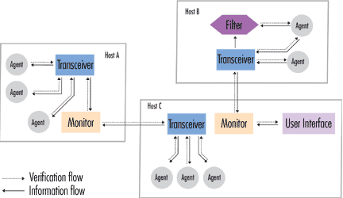
An AAFID compliant representation of an intrusion detection system employing autonomous agents
NETWORK BASED INTRUSION DETECTION SYSTEM (NIDS)
An intrusion detection system (IDS) that monitors activity on a network is NIDS
Network based intrusion detection system scans traffic on network, looking for anything that seems suspicious that might indicate an attack. A NIDS generally identifies malicious traffic by comparing traffic patterns to a database of known attack signature. If a traffic event exceeds the threshold level, the event is logged and other action can be taken such as altering an administrator or closing a port to block the traffic. Configuring the threshold level is a delicate matter since setting the threshold too high can result in numerous false positive that waste administrators time as they investigate suspicious attack and configuring it too low can allow intruders to penetrate network defense and compromise network security.
All traffic flowing through the network is analyzed for evidence of attempted intrusion. NIDS usually resides at a choke point on the perimeter of the network or on critical network segments where the server resides. A limitation of an NIDS is that it is difficult to implement in switched networks, though some Ethernet switch vendors are starting to incorporate embedded IDS within switches and provide monitoring ports for connecting a NIDS to switch’s backplane. Some of the popular NIDS products on the market include RealSource from the Internet SecuritySystems, SecureNet from Intrusion.com. The open source tool SNORT is a free NIDS tool that is popular with the security community.
A NIDS works well when deployed either at a choke point on the perimeter of a network where all inbound traffic must enter or on a shared network segment such as a local area network(LAN) with hubs. A NIDS has difficulty with switched networks since switched ports are designed to isolate traffic from each other. This limitation can be overcome in several ways:-
- By installing agents (also called taps or monitors) on remote network segments to capture and forward traffic to NIDS.
- By using switches that support port spanning to allow traffic to be copied to a special monitoring port where the NIDS is attached
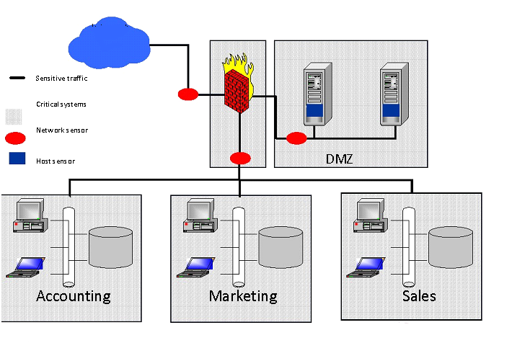
Advantages:
- the sensors can be secured well as they "only" observe traffic
- you can detect scans better - on the basis of signatures... you can "filter" traffic (actually, we will show later that this is not always the case)

Disadvantages:
- the probability of so called false negatives (attacks are not detected as attacks) is high as it is difficult to control the whole network
- mostly, they have to operate on encrypted packets where analysis of packets is complicated
Examples:
- NetRanger ,Dragon ,NFR ,Snort ,DTK ,ISS RealSecure
HOST BASED INTRUSION DETECTION SYSTEM (HIDS)
An intrusion detection system that monitors activity on a single host

A host based intrusion detection system (HIDS) is generally agent Software that resides
on a host and monitors for suspicious activity. Such activity might include attempts to modify System files or the registry. HIDSs typically work by monitoring event logs and other logs on the system and by using file system notification to detect attempts to modify system dynamic link libraries (DLLs). HIDSs may also monitor incoming network traffic looking for suspicious events such as multiple failed authentication events. When suspicious activity is detected, the HIDS notifies its management station. Centralized software that controls HIDS deployed on multiple cross.

Managing large numbers of HIDSs can be a complex task, so deployment is usually limited to critical servers exposed to hostile traffic, such as webservers or mailServers located in demilitrizedzone (DMZ) of a firewall protected network. HIDSs are generally used along with a network based intrusion detection system (NIDS) to ensure the greatest level of security against intrusion. While NIDS are generally platform independent in operation. HIDSs are agent software designed for specific operating system platforms.

There are numerous HIDSs available in the market today. Some popular ones include Centrax from Cyber-Safe, Real Secure and ServerSensor from Internet security system.

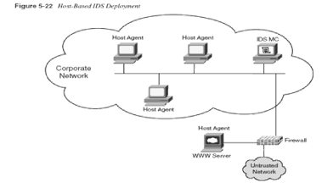
Advantages:
- you "see" the impact of an attack and can react better on it
- you can recognize Trojan horses etc. better as the available information/possibilities are very extended
- you can detect attacks which cannot be detected by Network based IDS because traffic is often encrypted
Disadvantages:
- they are not good in recognizing scans
- they are more vulnerable to DoS attacks
- The analysis of operating system audit trails is very time-consuming because of its size.
Examples:
- Tripwire ,SWATCH ,DragonSquire ,Tiger ,Security Manager

IMPLEMENTATION

There are various approaches to how IDS product works. The most popular method is Signature Detection, which involves matching network traffic to a database of thousand of known intrusion signatures. Important to implementation of such system is regular updating of the signature database.
Another approach is Anomly detection.
An Anomaly-Based Intrusion Detection System, is a system for detecting computer intrusions and misuse by monitoring system activity and classifying it as either normal or anomalous. The classification is based on heuristics or rules, rather than patterns or signatures, and will detect any type of misuse that falls out of normal system operation. This is as opposed to signature based systems which can only detect attacks for which a signature has previously been created.
In order to determine what attack traffic is, the system must be taught to recognize normal system activity. This can be accomplished in several ways, most often with artificial intelligence type techniques. Systems using neural networks have been used to great effect. Another method is to define what normal usage of the system comprises using a strict mathematical model, and flag any deviation from this as an attack. This is known as strict anomaly detection.
This involves looking for unusual traffic patterns that may indicate an attack in progress and is generally accomplished using statistical techniques to compare current traffic with a baseline of normal traffic established previously.
Anomly detection has an advantage over signature detection in that it is able to detect new and undocumented form of attack. The downside is that if the threshold for detection is set too high, large number of false positive are generated. The job of the administrator is thus complicated by having to sort out the real from the false events.
Another technique used in intrusion detection is monitoring file system to look for attempts to replace or modify key system or log files. HIDS products generally incorporate this kind of approach, in addition to scanning system logs for unusual events.

Development
A preliminary concept of an IDS began with James P. Anderson and reviews of audit trails. An example of an audit trail would be a log of user access.
Fred Cohen noted in 1984 that it is impossible to detect an intrusion in every case and that the resources needed to detect intrusions grows with the amount of usage.
Dorothy E. Denning, assisted by Peter Neuman, published a model of an IDS in 1986 that formed the basis for many systems today. Her model used statistics for anomaly detection, and resulted in an early IDS at SRI named the Intrusion detection expert system (IDES), which ran on Sun Workstations and could consider both user and network level data. IDES had a dual approach with a rule-based Expert System to detect known types of intrusions plus a statistical anomaly detection component based on profiles of users, host systems, and target systems. Lunt proposed adding an Artificial neural network as a third component. She said all three components could then report to a resolver.
The Multics intrusion detection and alerting system (MIDAS), an expert system using P-BEST and LISP, was developed in 1988 based on the work of Denning and Neuman. Haystack was also developed this year using statistics to reduce audit trails.
In 1990, the Time-based inductive machine (TIM) did anomaly detection using inductive learning of sequential user patterns in Common LISP on a VAX 3500 computer. The Network Security Monitor (NSM) performed masking on access matrices for anomaly detection on a Sun-3/50 workstation. The Information Security Officer's Assistant (ISOA) was a 1990 prototype that considered a variety of strategies including statistics, a profile checker, and an expert system. ComputerWatch at AT&T Bell Labs used statistics and rules for audit data reduction and intrusion detection.
Then, in 1991, researchers at the University of California created a prototype Distributed intrusion detection system (DIDS), which was also an expert system. The Network anomaly detection and intrusion reporter (NADIR), also in 1991, was a prototype IDS developed at the Los Alamos National Laboratory's Integrated Computing Network (ICN), and was heavily influenced by the work of Denning and Lunt. NADIR used a statistics-based anomaly detector and an expert system.

SNORT
A popular open source intrusion detection tool
Snort is a free and open source Network Intrusion prevention system (NIPS) and network intrusion detection system (NIDS) capable of performing packet logging and real-time traffic analysis on IP networks. Snort was written by Martin Roesch and is now developed by Sourcefire, of which Roesch is the founder and CTO. Integrated enterprise versions with purpose built hardware and commercial support services are sold by Sourcefire.
Snort is a simple but effective network intrusion detection system(NIDS), that can be used to analyze Internet protocol(IP) traffic in real time , looking for evidence of intrusion , snort can detect a wide range of exploit , including stealth scans , server message blocks(SMB) probes, stack fingerprinting and more. The tool includes a flexible rule based architecture and an extensible detection system that can incorporate custom module for enhancing its capabilities. Snort also can analyze the flow of hypertext transfer protocol (HTTP) traffic and perform stateful pattern matching.
Snort performs protocol analysis, content searching/matching, and is commonly used to actively block or passively detect a variety of attacks and probes, such as buffer overflows, stealth port scans, web application attacks, SMB probes, and OS fingerprinting attempts, amongst other features. The software is mostly used for intrusion prevention purposes, by dropping attacks as they are taking place. Snort can be combined with other software such as SnortSnarf, sguil, OSSIM, and the Basic Analysis and Security Engine (BASE) to provide a visual representation of intrusion data. With patches for the Snort source from Bleeding Edge Threats, support for packet stream antivirus scanning with ClamAV and network abnormality with SPADE in network layers 3 and 4 is possible with historical observation. (These patches seem to be no longer maintained)
Snort is available for a wide range of platforms, including most versions of UNIX/LINUX and Microsoft Windows platform. Current version 2.1 is licensed under the general public license (GPL).

INTRUSION PREVENTION SYSTEM (IPS)
An intrusion detection system that can also react to intrusion by blocking them

Traditional IDSs are passive system that can detect intrusion but do nothing to block them. Instead, it is up to the administrator to review IDS logs and respond to alerts, closing ports on firewall and taking other steps to prevent intruders from gaining a foothold.
An Intrusion Prevention System is a network security device that monitors network and/or system activities for malicious or unwanted behavior and can react, in real-time, to block or prevent those activities. Network-based IPS, for example, will operate in-line to monitor all network traffic for malicious code or attacks. When an attack is detected, it can drop the offending packets while still allowing all other traffic to pass. Intrusion prevention technology is considered by some to be an extension of intrusion detection (IDS) technology. The term "Intrusion Prevention System" was coined by Andrew Plato who was a technical writer and consultant for NetworkICE.
Intrusion prevention systems (IPS) evolved in the late 1990s to resolve ambiguities in passive network monitoring by placing detection systems in-line. Early IPS was IDS that were able to implement prevention commands to firewalls and access control changes to routers. This technique fell short operationally for it created a race condition between the IDS and the exploit as it passed through the control mechanism. Inline IPS can be seen as an improvement upon firewall technologies (snort inline is integrated into one), IPS can make access control decisions based on application content, rather than IP address or ports as traditional firewalls had done. However, in order to improve performance and accuracy of classification mapping, most IPS uses destination port in their signature format. As IPS systems were originally a literal extension of intrusion detection systems, they continue to be related.
Intrusion prevention systems may also serve secondarily at the host level to deny potentially malicious activity. There are advantages and disadvantages to host-based IPS compared with network-based IPS. In many cases, the technologies are thought to be complementary.
A recent trend in firewall products is for vendors to include reactive intrusion detection technology that can automatically reconfigure the firewall when an intrusion is detected. Such products are sometimes called INTRUSION PREVENTION SYSTEMS (IPS) and indicate a blurring of the line separating firewall products from IDS platform.

Contrast with Intrusion Detection Systems (IDS)
IPS systems have some advantages over intrusion detection systems (IDS). One advantage is they are designed to sit inline with traffic flows and prevent attacks in real-time. In addition, most IPS solutions have the ability to look at (decode) layer 7 protocols like HTTP, FTP, and SMTP which provides greater awareness. However, when deploying network-based IPS (NIPS), consideration should be given to whether the network segment is encrypted since not as many products are able to support inspection of such traffic.
IPS can do more than just drop packets. Because an IPS is inline, it does not have to interpret the network stack. An IPS can correct CRC, unfragment packet streams, prevent TCP sequencing issues, and clean up unwanted transport and network layer options. Intrusion detection system evasion techniques were made famous by Insertion, Evasion, and Denial of Service: Eluding Network Intrusion Detection and can be addressed with IPS. IPS that has evolved from IDS tends to still have these issues for the software was designed with detection and not the concept of correction in mind.

CONCLUSION

In this paper we proposed a systemic framework for intrusion detection. This framework consists of classification, architecture, and frequence episodes on its models that can be used to (automatically) construct detection models. The accuracy of the detection models depends on sufficient training data and the right feature set. We suggested that the architectures and frequent architectural algorithms can be used to construct the consistent patterns from detection and prevention model. These frequent patterns form an abstract summary of a detection model, and therefore can be used for the security purposes.
REFERENCE
Encyclopedia of Security, Wikipedia, Google, etc.

