An Active Testing Model for Tracking
Roads
In Satellite Images

1. Mr.V.D.Ambeth Kumar, Lecturer In Panimalar Engineering College
Department of Computer Science and Engineering
Varadharajapuram, nasarathpetai, poonamallee, pincode-602 103
Email-id : ambeth_20in@yahoo.co.in

Abstract— Eventhougth lines in images provide important information, complete line detection is being crucial. Without focusing on the line thickness, the existing algorithms provide only the methods for extraction of line positions using directional derivatives. The proposed method presents a novel wide line detector using an isotropic non-linear filter to extract the line completely without any derivatives. Isotropic responses provided by circular masks is the base of the line detector. This paper has an advantage of automatic selection of parameters and provides the relationship between the size of the circular masks and the width of detected lines. One of the major application is the tracking of roads given by the satellite images along with its width accurately. But the feasibility and the effectiveness of line detection can be improved by our method.

Index Terms— Curvilinear structures, feature extraction, isotropic nonlinear filter, line detection, wide line detector.

I. INTRODUCTION

HE analysis of images in the fields of pattern recognition and computer vision generally requires the detection of
lines, also called curvilinear structures, from grayscale images. Line detection plays an important role for the success of higher level processing such as matching and recognition [1]–[6]. So far, many algorithms for line detection have been developed for different applications. The Hough transform [7]–[9], which is a widely used line detection method, was initially proposed to find analytically defined curvilinear structures (e.g., straight lines, circles, ellipses, etc.). Although the generalized Hough trans- form [10] can be used to detect arbitrary curvilinear structures in theory, it requires the complete specification of the exact shape of the curvilinear structure which is very difficult and even un- feasible for complex curvilinear structures in practice. One pow- erful approach is based on edge extraction and treats lines as objects with parallel edges [11]–[16]. An edge extraction algo- rithm [17] is first used to find all the edges in the image. The edgeimage is then analyzed to find the particular lines. However,the success of this approach depends on the accuracy of edges and the line thickness was not considered. Another popular ap- proach is to use differential geometric properties to extract lines as ridges and valleys in the image [18]–[23]. A popular ridge detector [24] is based on the eigenvectors of the Hessian matrix which is given by the local second order derivatives. This de- tector extracts the ridges as points for
T

which the intensities are maxima or minima in the main principal curvature direction, i.e., the direction of the maximum eigenvalue of the Hessian matrix. Nevertheless, this approach is sensitive to noise due to the use of second order of derivatives.
Although the line position detection is important, it would be useful if all the line’s pixels (i.e., the pixels that comprise the full cross-sectional width) were also extracted. Koller et al. [25] presented an edge-based line finder for extracting line structures and their widths. This line finder employs the first derivative of Gaussian edge detectors and combines their outputs nonlinearly. This approach can detect lines of arbitrary widths by iterating in scale space and selecting as the line width the scale that yields the maximum of a scale-normalized response. However, due to the quantization of the scale space, this approach is computa- tionally expensive and gives only a coarse estimate of the line width. Steger [26] proposed a ridge-based line detector which uses a line model with an asymmetrical profile to remove the bias of the line position as well as to extract the line width. This line detector overcomes the problem that the ridge-based line detection approach will return inaccurate line locations when the contrast on one side of the line is different from the contrast on the other side of the line. Moreover, since Gaussian masks are used to estimate the derivatives of the image, the line detector can scale to lines of arbitrary widths. Although this approach is useful for line width information detection, it has its limitations. Since this approach extracts lines as the maxima of the mag- nitude of the second directional derivatives, it can detect only salient lines. Also, once the selected becomes so large that neighboring lines start to influence each other, the line model will fail and the results will deteriorate.


The two line detection approaches, however, do not detect the
whole of the line. A line, mathematically, is a 1-D figure without thickness, but an image line generally appears as a line of one or several pixels wide, i.e., as a thin/narrow or thick/wide line, having linear or curvilinear structures. In image processing and pattern recognition applications, line thickness or a line’s full cross section is important in, for example, segmenting multiple orientation lines [27], in recognizing roads, railroads, or rivers from satellite or aerial imagery [11], [21], in extracting anatom- ical features in medical imaging for diagnoses [24], [28], [29],

and in detecting biometric traits for personal authentication [30].
It is, thus, important to detect not simply the line edges but rather
the whole of the line.
In this paper, which has partly appeared in a preliminary form in [31], we present a robust method to detect the whole of the line, which we call the wide line detector. This wide line de- tector is implemented by employing a nonlinear filter without the use of any derivative. Isotropic responses are obtained by using circular masks which contain either a normalized constant weighting or a Gaussian profile. We restrict the sizes of circular masks so as to ensure that lines of different widths can be ex- tracted in their entirety. We also design a line model which can analyze the robustness of the proposed wide line detector and which allows the automatic selection of parameters.
The paper is organized as follows. Section II introduces the
line model and the relevant design issues. Section III presents the isotropic nonlinear filter based line detection method. In Section IV, we analyze the robustness of the proposed method and show how to automatically select parameters. Section V offers our discussion.
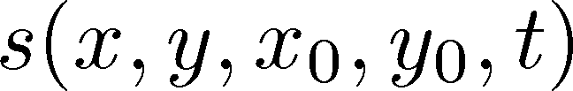

II. MODELDESIGN
In this section, we first introduce the models for line profiles in 1-D and then describe the design issues for the proposed line detection method with particular reference to 2-D line detection.

A. One-Dimensional Line Profile Model
Many line detection approaches model lines in 1-D as bar- shaped [25], i.e., the ideal line of width and height 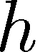 is assumed to have a profile given by [26]




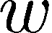

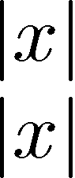 (1) However, the flatness of this profile is rarely found in real im-

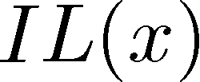





ages. Generally speaking, in terms of different gray levels, there are three regions in a line image: the line part having a gray level
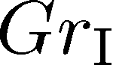, the edge region having a gray level , and the back- ground having a gray level . As an example, consider a bright line on a dark background, then we get 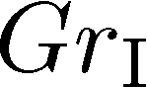 

. In this paper, therefore, a model for the common line pro-
file in 1-D, the edge-based bar-shaped line, is defined as

 (2)

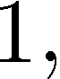

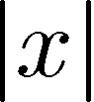

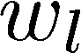

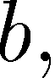



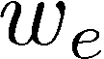

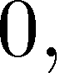

where and 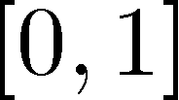 and is a scale or a vector, which represents height in the 1-D case and intensity in the 2-D case. For a bright line, also called a positive line, . For a dark line, also called a negative line, .

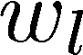



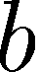



B. Two-Dimensional Line Detection
We now address the design issues for the proposed line detec- tion method. Fig. 1 shows a dark line 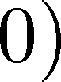 in 2-D based on the 1-D ideal line model as in (1). A circular mask is shown at four image positions in Fig. 1. The detector groups pixels whose brightness is similar to the brightness at the center of the mask



Fig. 1. Four circular masks at different positions on a line image based on the
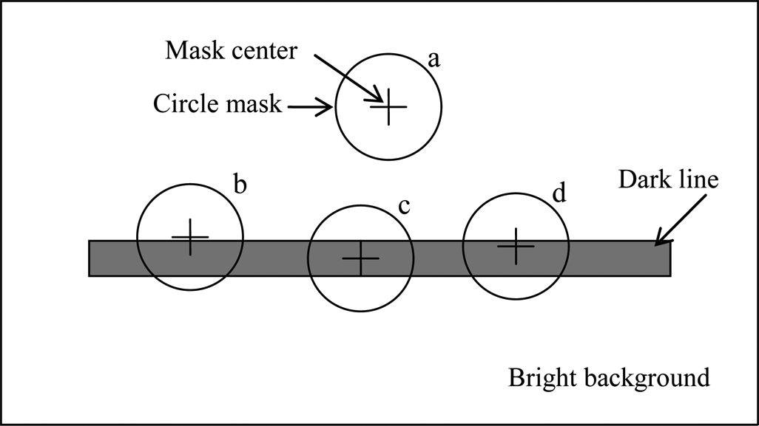

1-D ideal line model IL as in (1).

into a weighted mask having similar brightness (WMSB). This similarity can be measured by
if (3)

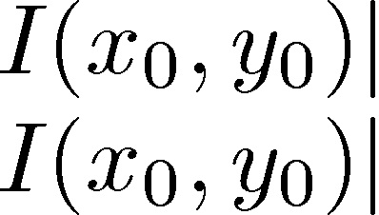

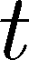

if

where 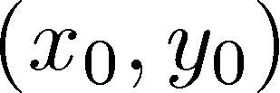 is the coordinate of the center, is the coor- dinate of any other pixel within the mask, is the bright- ness of the pixel 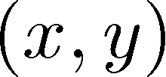,and is the brightness contrast threshold. The summation of the outputs within the circular mask gives the mass of WMSB. According to (3), when the center of the mask moves to a line on the image, the WMSB reaches the global maximum as the mask lies in a flat region of the image
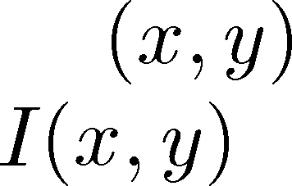

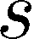

(as the mask shown) and decreases when the center of the mask is very near a straight edge (as shown in the mask ) and decreases even further when very near the straight edge while remaining nonetheless in the line region (as shown in the mask
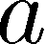

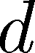). Therefore, the smaller the WMSB mass, the larger the fea- ture response. This is similar to the idea used for edge extraction and corner detection in [32]. Hence, to detect a line completely, the WMSB mass of any pixel on the line should be less than that of any background pixel. Now let us consider a general situation: a line with an edge re- gion in 2-D based on the common 1-D line profile as in (2). Fig. 2 provides an illustration in which a dark line is bounded by a gray band against a white background. In proximity to the lines are five circular masks. According to (3), in order to com- pletely detect the line it is necessary that . It is obvious that no matter what value and take in (2), the three different gray level regions (Fig. 3) have only four relations

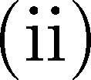

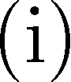


(4) Now the question is how the edge region affects the WMSB

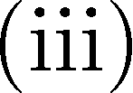

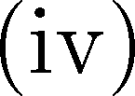

mass of the line and the background pixels and thereby in- fluences line detection. These matters will be considered in Section IV-B.
III. LINE DETECTION METHOD
The wide line detector is implemented to give isotropic line responses by applying a set of rules in a circular mask. Using

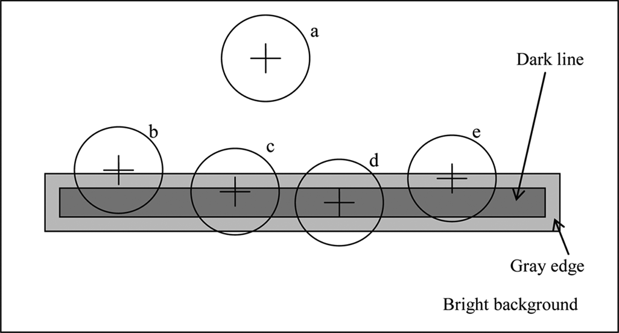

Fig. 2. Five circular masks at different positions of a line image based on the
1-D common line profile GL as in (2).

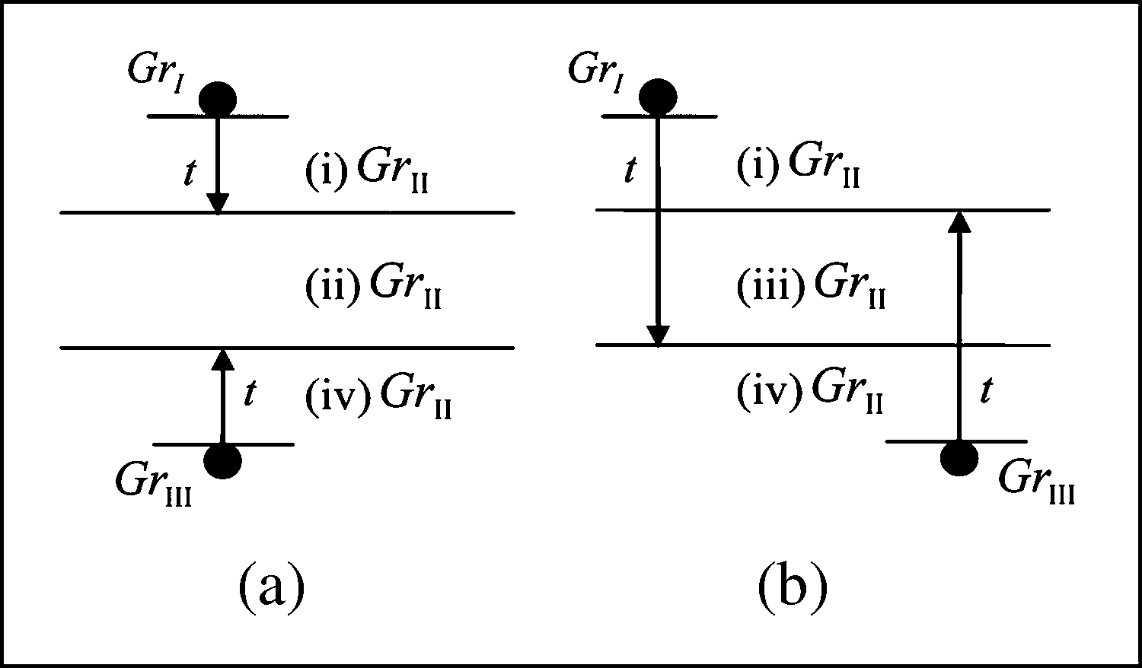

Fig. 3. Illustration of gray-level relations between three regions. Gr , Gr , and Gr are gray levels of the line part, the edge region, and the background, respectively. The difference of the gray levels between the line (Gr ) and the background (Gr ) is larger than the brightness contrast threshold t (a) with or

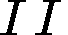





(b) without larger than 2 t; (i)–(iv) show the corresponding relations in (4), respectively.
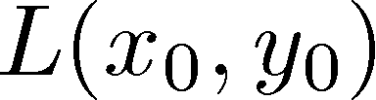

a square kernel, the circular mask is digitally approximated to either with a constant weighting

if 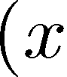 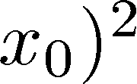 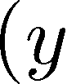 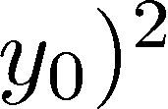 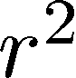

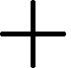

otherwise
(5)
or with a Gaussian profile
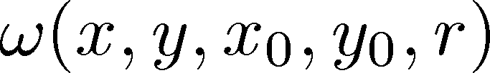

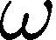

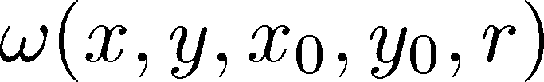 (6)

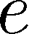

where is the radius of the circular mask. The normalization of the circular mask is obtained by the rule
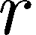

(7)

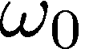

As is usual when locally processing an image, the mask is centered on each pixel in the image and the brightness of any other pixel within the mask is compared with that of the center pixel. The comparison is determined by the rule defined in (3) along with a weighting function
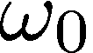

(8)
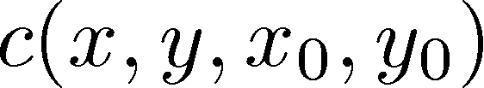

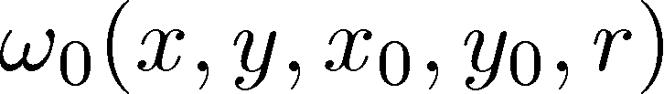

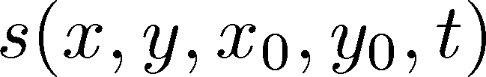

TABLE I
DEVIATION OF FUNCTION sec h((I (x; y) I (x ;y ))=t) FROM (3). HERE, c




IS THE SUBTRACTION OF (11) FROM (3), AND jcj IS THE ABSOLUTE VALUE OF c

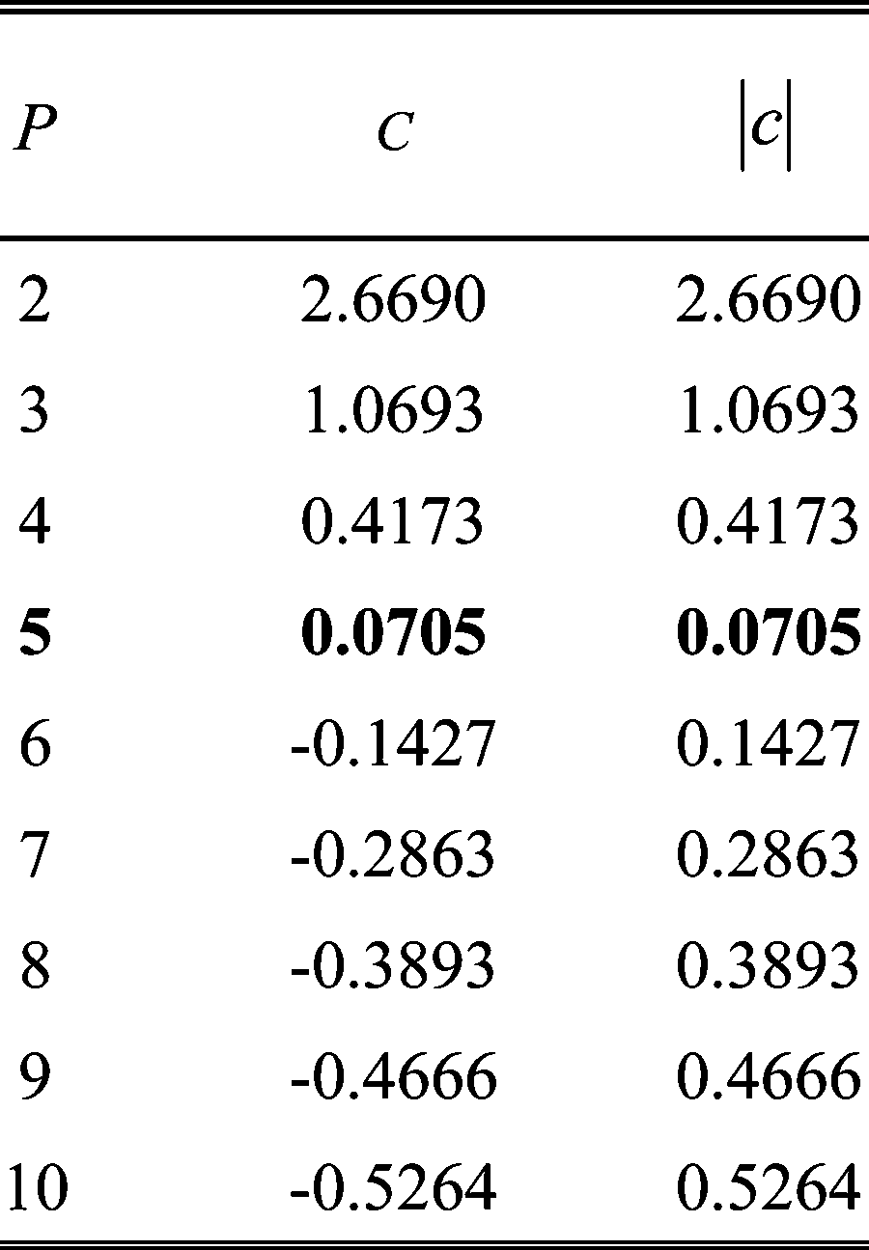

where is the output of the weighting comparison. This compar- ison is done for each pixel within the mask. The WMSB mass of the center 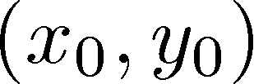 is given by


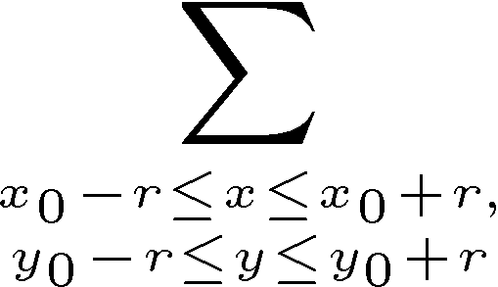 (9) The initial line response is the inverse WMSB mass obtained
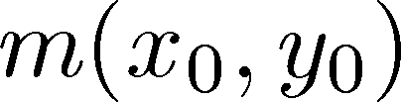

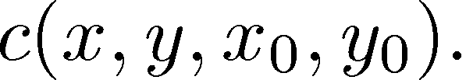



by

if, (10)

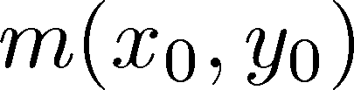

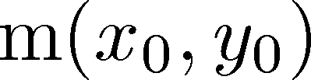

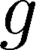

otherwise

Here, is the geometric threshold and 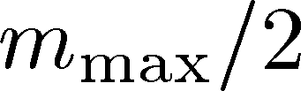, where

is the maximum value which can take (usually


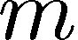

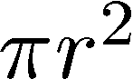). The fixed threshold for (10) is the theoretical optimum which is shown in the later analyses.

According to (3), the comparison varies dramatically when

a slight change of the brightness difference occurs very near the brightness contrast threshold . In order to produce a smooth profile near the brightness contrast threshold, a hyperbolic se- cant function was used to give a much more stable and sensible version of (3) and is defined as

(11)

where 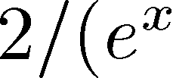 . The use of the fifth power in- troduces the minimum difference from (3), as shown in Table I. This equation is plotted along with (3) in Fig. 4, where is set to 10. It can be seen that, compared with (3), (11) produces

a smoother profile and does not have too large an effect on

as a pixel’s brightness changes slightly. This equation makes a tradeoff between stability about the threshold and the original requirement of the function, which is to take pixels having in- tensities similar to that of the center together into the mass of the circular mask.
Although the wide line detector is isotropic and can detect
the whole of a line without the need to find the direction of line pixels, line direction is still necessary either for postprocessing or for application requirements. From (10), the direction of a

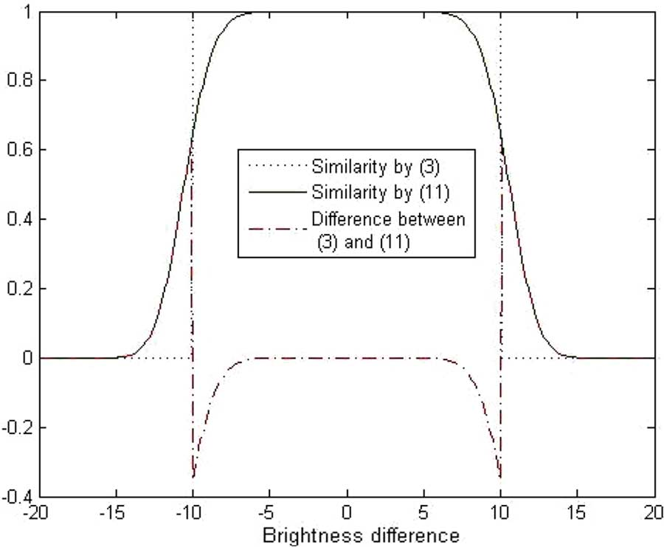

Fig. 4. Brightness difference versus the similarity functions defined in (3) and
(11), respectively. Here, the brightness contrast threshold t is set to 10.

pixel with a nonzero line response is determined by finding the longest axis of symmetry

how the two parameters affect the line detection result and then present approaches for automatically selecting the two parame- ters so that the proposed method is robust.

A. Radius of Circular Mask,

Obviously, complete line detection requires that the circular mask should at least be bigger than the line width. The radius of the circular mask must, therefore, be restricted so as to en- sure that the whole of the line can be detected using the inverse WMSB mass. In this section, we analyze the relationship be- tween the radius of a circular mask and the width of the line detected , first with regard to circular masks with a normal- ized constant weighting, and then those with a Gaussian profile.

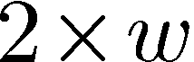

1) Circular Mask With Normalized Constant Weighting: In
this section, we employ the line mode to discuss the relation- ship between the size of circular mask with constant weighting and the width of detected line.

Definition 1: Given an image region and a line of width


, for any given point , the distance of to , 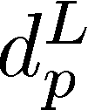, is defined by the rule

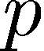

if 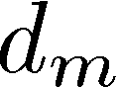 

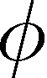

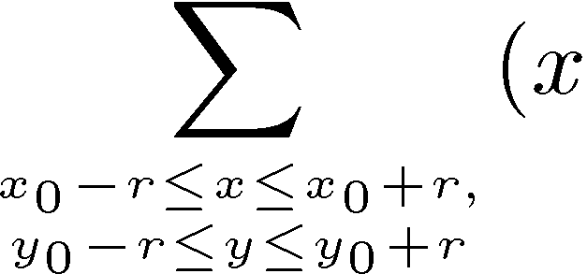

otherwise (12)

(13)
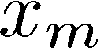

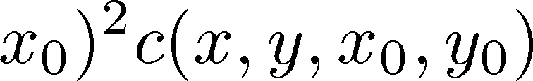

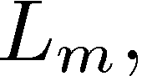

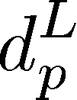

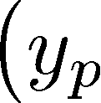

where 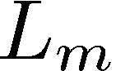 is the middle axis of in the line direction.

(17)

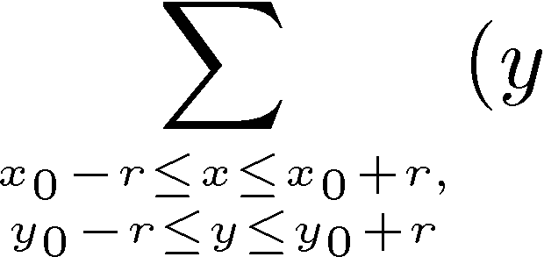 (14)
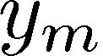

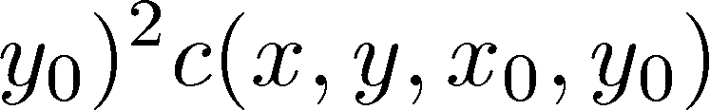

(15)

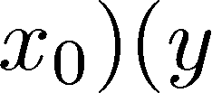

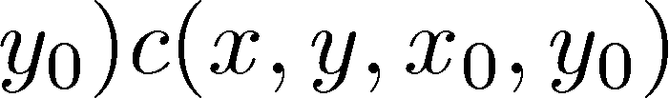

where 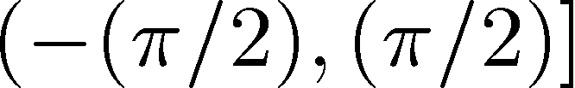. The value of is exactly correct only for lines parallel to one of the coordinate axes or at an angle of 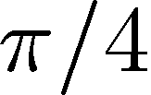 to a coordinate axis. In other cases, deviations of the calculation of will occur. However, such deviation of from the line orientation is small and can be ignored.



In some cases, only dark or bright lines are required, for ex- ample, with reference to blood vessels in X-ray images (dark lines generally required) and aerial images (bright lines gener- ally required). Introducing a step function, , we can im- plement the wide line detector to extract bright or dark lines according to need

Definition 2: Let  denote a circle region with radius in an image. The mass of point , the center of the circle region, is defined as

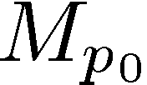 (18)

if

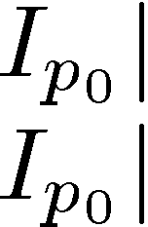

if (19)
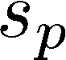

where is any other point in the circle region and 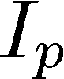 is the intensity of point .

Proposition 1: Denote the background



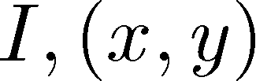 . For each , , if , there exist the following.



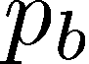

1) is monotonically decreasing relative to 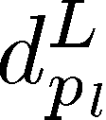 and

for each .

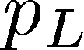

2) is monotonically increasing relative to and

for each



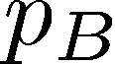

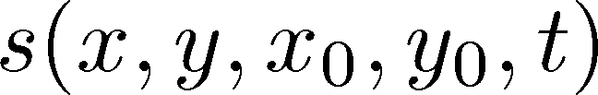 (16)

where else and



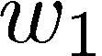

if dark line

if bright line.

IV. PARAMETER SELECTION

The proposed line detection method requires two parame- ters—the radius of the circular mask and the brightness con- trast threshold . In this section, we provide analyses to show

.
Proof: Assume that the center of circular region is the coordinate origin. Rotate the coordinate axes about the origin so that the axis is parallel to , as shown in Fig. 5. We define

and , where

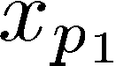

and are the coordinates of the right- and left-most intersection points of the circle region
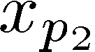



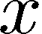

and the line , respectively. As there exists 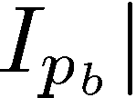 , for each , , according to (18) and (19), we can get

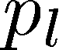

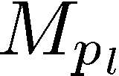  and 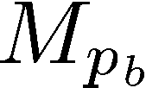 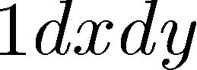.

1) For each , when the circle is centered on [as shown in Fig. 5(a)], we have (20), shown at the bottom

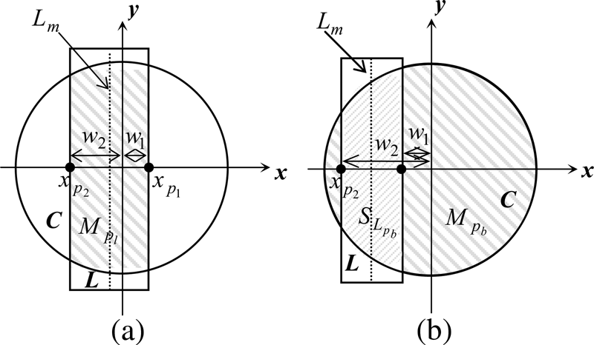
Fig. 5. Illustration of Proposition 1 and its proof.

of the page, where . For convenience, denote

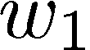

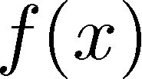 (21)

where . Then, the (20) can be rewritten as



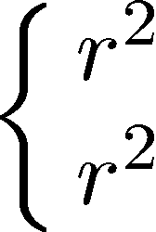

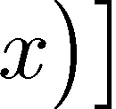

where 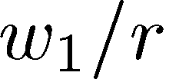. It is obvious that 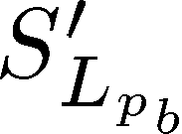 . Therefore,

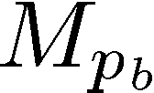 is monotonically increasing relative to 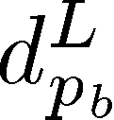 . Hence,
for each 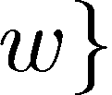, reaches the minimum

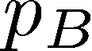

value , and takes the minimum value

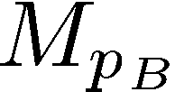 (23)

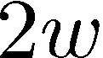

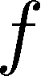


The meaning of Proposition 1 is that, no matter what size of the circular mask, the smaller the distance of the pixel to , the larger the WMSB mass if the pixel is on the line, while the smaller the WMSB mass if the pixel on the background. Conse- quently, pixels on the middle axis of a line take the local max- imum value of the WMSB mass, whereas pixels on the back- ground very near the edges of the line take the local minimum WMSB mass. As mentioned in Section II-B, in order to detect a line completely, the maximum of the WMSB mass that the line pixel can take should be less than the minimum that the back- ground pixel can take. Therefore, according to Proposition 1 and its proof, from (22) and (23), we get

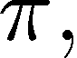

where . It is obvious that the derivative 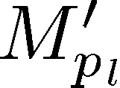

. Therefore, is monotonically decreasing relative

to . Hence, when , and takes
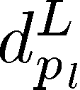

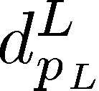

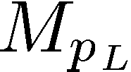

where .

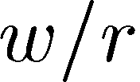

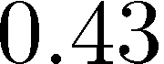

(24)

the maximum value

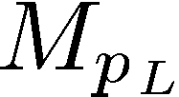

(22)
Fig. 6 illustrates the inequality relations defined by (24). We can see that only meets the inequality. Given the line width, the smaller the value, the larger the mask size . There
is a tradeoff to be made here as a smaller ratio means a slower
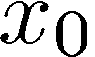

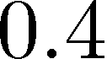

2) For each , when the circle is centered on

[as shown in Fig. 5(b)], we have 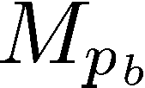 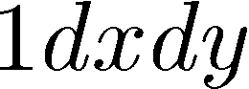

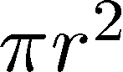 and

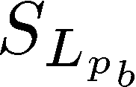

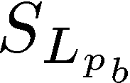

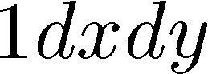

detection yet the use of a larger ratio, and, therefore, a smaller mask will undermine line detection. Hence, we set by experience. The relationship between the width of detected line,
, and the radius of a constant weighting circular mask, ,

is

(25)

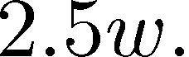

According to (22), the maximum of WMSB mass which line

pixels can take is . Therefore, the geometric threshold used in (10) is equal to

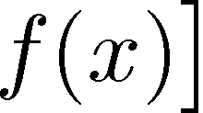 .

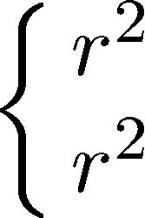



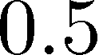

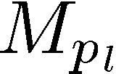

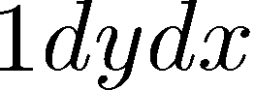

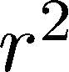

(20)

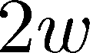

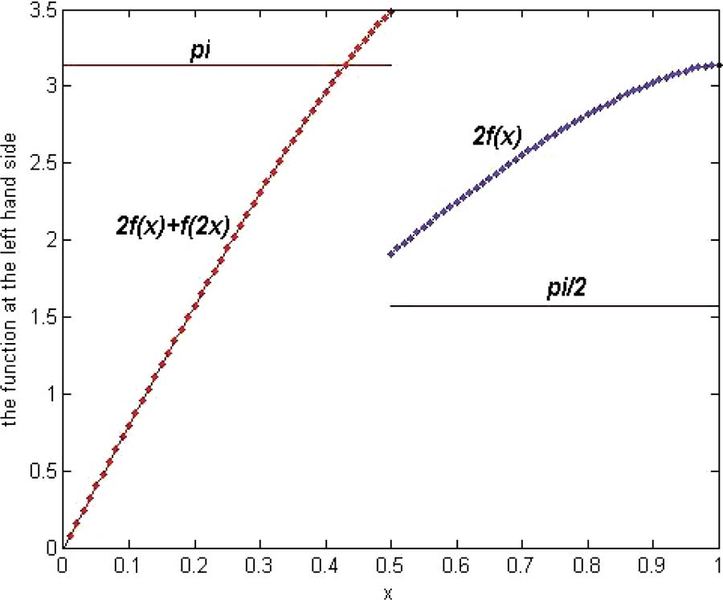

Fig. 6. Illustration of the inequality relation about the ratio of the width of the line detected to the radius of a circle mask with normalized constant weighting.

2) Circular Mask With Gaussian Profile: Now we discuss the relationship between the width of the line detected and the size of a circular mask with a Gaussian profile. Although Proposition

1 is for a constant weight, it is evident that we can get the same conclusion for a Gaussian weight. That is, the WMSB area of
a line reaches a local maximum when the line passes through
the center of the circular mask. Assume that a circle with a radius has a density and a line of width

traverses the center of the circle. Let  denote the part of

the line within the circle. According to the definition of line response [see (10)], if a line of width is to be completely detected by using a Gaussian mask with radius , it requires

(26)

which is equivalent to

(27) The right hand side can be simplified as

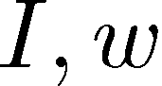

This equation determines the relationship between the width of the line detected and the radius of a circular mask with a Gaussian profile. Given a mask with a radius , the critical width of the line detected is obtained when the left and right argu- ments of (29) are equal. As the analytic form of the left function is not available, we provide only the approximate critical width

of the line detected as shown in Table II, as well as the corre- sponding digital approximations. Therefore, given a Gaussian profile mask of radius , a line is definitely detected if it is not wider than the digital approximation of the corresponding crit- ical width.

B. Brightness Contrast Threshold,

Ideally, a line is defined as the profile of two distinctive re- gions as described in Section II-A (see Fig. 1). However, in gen- eral, there are shaded areas between the two distinctive regions, as shown in Fig. 2. Here, we call such area as the edge region. Therefore, we have to take into account the influence of the edge region on the WMSB mass, which is related to the brightness contrast threshold that defines the minimum contrast of the de- tected features. In this section, we first analyze the relationship between the brightness contrast threshold and the WMSB mass and then give the automatic selection of a proper .

Proposition 2: Given a line of width bounded by an edge region of width denoted by



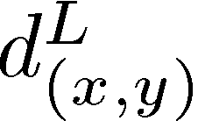 and a circle of radius

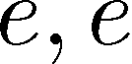



with the constraint . Define the background

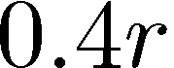

. For each , ,





, if 1) and 2) , there exists

. Here, the sign “ ” means

Therefore

(28)

(29)

much less than.
Proof: From Proposition 1, condition 2) can be rewritten as 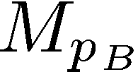. As discussed in Section II-B, there are only four relations between three different gray-level regions.

Case 1) and 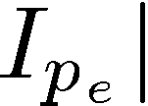 . Suppose 

, then is a line with a width of 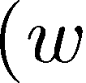

and . According to Definition 1, we

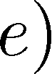

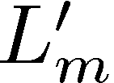

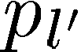

always have 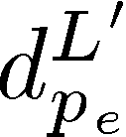. From Proposition 1, for each , is monotonically decreasing
relative to . Therefore, for each , ,

, we get 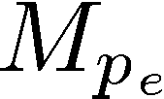 .

Case 2) and . From Propo-

sition 1, for each , when


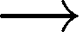



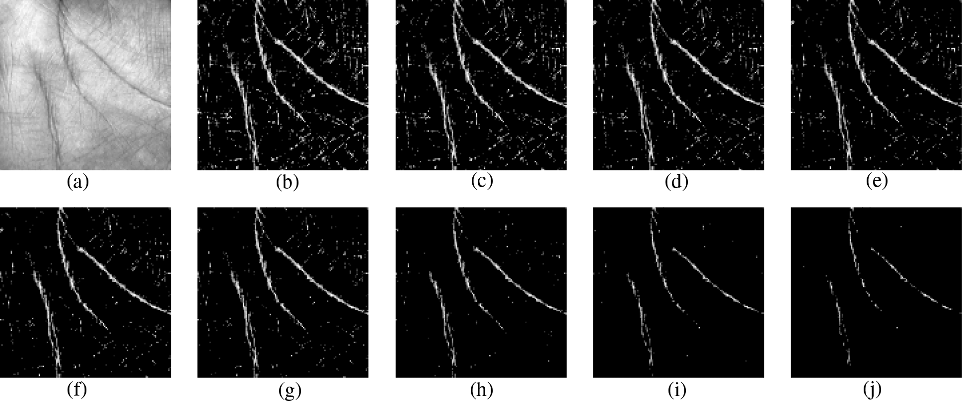

Fig. 7. (a) Segmented palmprint image. Palm-line response images obtained using brightness contrast thresholds t of (b) 6, (c) 7, (d) 8, (e) 9, (f) 10, (g) 11, (h) 15,
(i) 20, and (j) 25.

, approaches the maximum

value , and reaches the minimum value
. From , we always get . There- fore, for each , , , we have

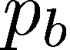

.

Case 3) and . According to

(18) and (19), we have 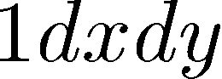 .

Obviously, for each , , , we always have .

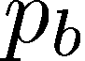

Case 4) and . Based on Proposi- tion 1, when , takes the maximum value

. Suppose  , then for each , when

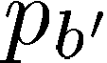

, 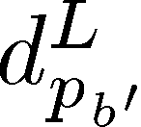 reaches the minimum , takes the minimum value 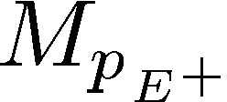 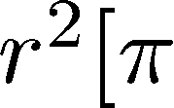 . Owing to , from Fig. 6, we can get . Therefore, for each , , , we

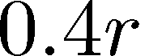



have 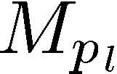 .

Hence, from Cases 1) and 2), if , we have

; from Cases 3) and 4), if , we have

.

From Proposition 2 and its proof, we conclude that for a given image, if the contrast between the edge region and the back- ground is less than the threshold , the edge region can be re- garded as one part of the line; otherwise, the edge region must be regarded as one part of the line. That is, for a given image, a large brightness contrast threshold may result in a “narrow” line being detected, while a small brightness contrast threshold must result in a “broad” line being detected. Therefore, the brightness contrast threshold qualitatively determines the width of lines detected.

Fig. 7 gives an example of line response images with different
. Here, dark line pixels are extracted directly from the input segmented palmprint image [see Fig. 7(a)] by using a constant weighting mask with a radius of 8 pixels. It can be seen that as the brightness contrast threshold increases, the number of false response pixels and true response pixels are both decrease. It is,

thus, necessary to select a proper to guarantee the detection of
the whole line. By experience, we defined as

(30)

where  is the standard deviation function,  means the nearest integer, and is the input image. According to (30), the brightness contrast threshold used in Fig. 7(a) is 9.

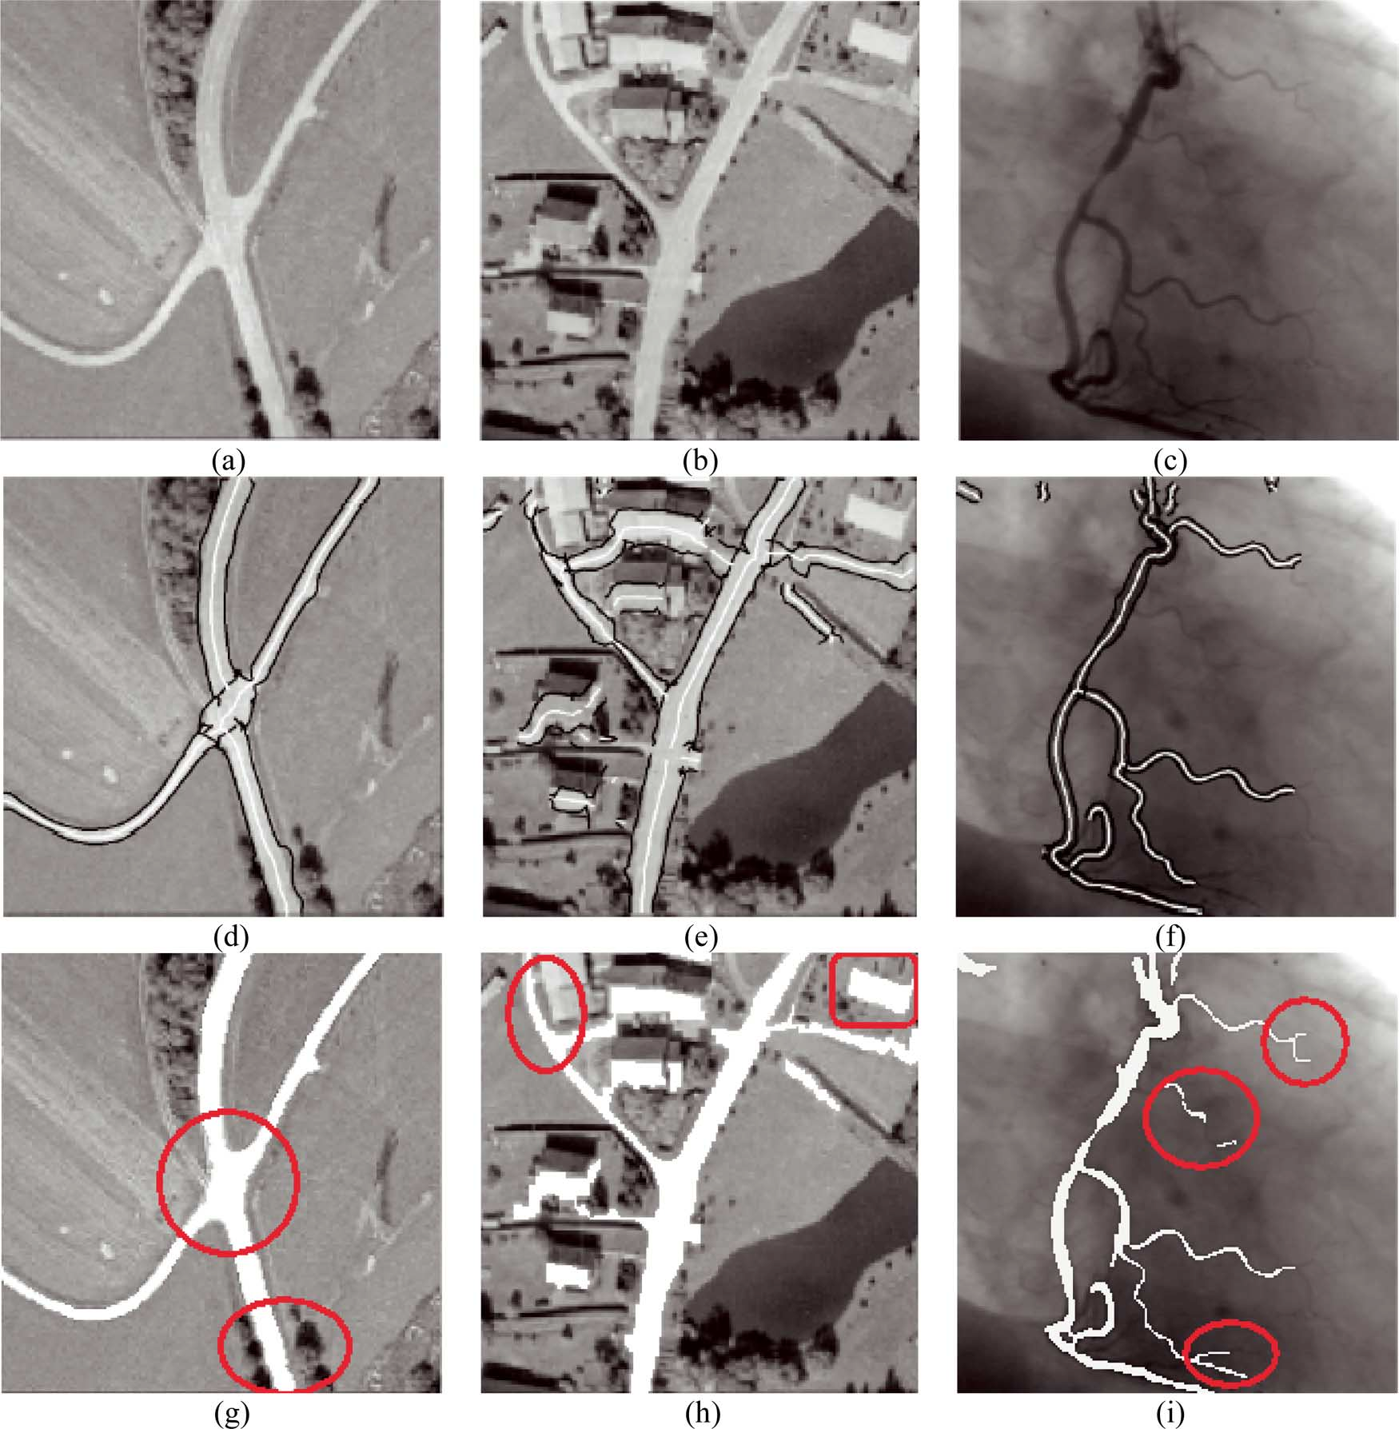

Fig. 9. (a), (b) Aerial images and (c) an X-ray image taken from [26]. (d)–(f) Extraction results of line positions and line widths reported in [26] where line
positions are displayed in white with the corresponding edges displayed in black. (g)–(i) Corresponding line detection results obtained using our wide line detector are drawn in whit

V. DISCUSSION

This paper presents a novel wide line detector for extracting a whole line by using an isotropic nonlinear filter. Unlike existing approaches, our method employs a hyperbolic secant formula based nonlinear filter to detect the whole of the line. Isotropic responses are obtained by using a circular mask either with a normalized constant weighting or with a Gaussian profile. The method is robust because of the automatic selection of two pa- rameters—the size of the circular mask and the brightness con- trast threshold. The line detection method works very well for a

range of images containing lines of different widths, especially for those where the width of lines varies greatly. Because the wide line detector is not dependent on the Gaussian kernel to detect lines, even narrow lines can be extracted well as long as the intensity difference between the narrow lines and the back- ground is larger than the brightness contrast threshold.

Finally it should be noted the proposed line method is used only for detection of lines on 2-dimensional images and so this method can be extended for line detection on 3-deimenisonal images.

REFERENCES
[1] D. Behar, J. Cheung, and L. Kurz, “Contrast techniques for line detec- tion in a correlated noise environment,” IEEE Trans. Image Process., vol. 6, no. 5, pp. 625–641, Jun. 1997.

[2] G. J. Genello, J. F. Y. Cheung, S. H. Billis, and Y. Saito, “Graeco-Latin squares design for line detection in the presence of correlated noise,”
IEEE Trans. Image Process., vol. 9, no. 4, pp. 609–622, Apr. 2000.

[3] G. M. Schuster and A. K. Katsaggelos, “Robust line detection using a weighted MSE estimator,” in Proc. Int. Conf. Image Processing, 2003, vol. 1, pp. 293–296.

[4] H. Li, W. Hsu, M. L. Lee, and H. Wang, “A piecewise Gaussian model for profiling and differentiating retinal vessels,” in Proc. Int. Conf.
Image Processing, 2003, vol. 1, pp. 1069–1072.

[5] E. R. Davies, M. Bateman, D. R. Mason, J. Chambers, and C. Ridgway,
“Design of efficient line segment detectors for cereal grain inspection,”
Pattern Recognit. Lett., vol. 24, pp. 413–428, 2003.

[6] Z. Y. Liu, K. C. Chiu, and L. Xu, “Strip line detection and thinning by
RPCL-based local PCA,” Pattern Recognit. Lett., vol. 24, no. 14, pp.
2335–2344, 2003.

[7] R. O. Duda and P. E. Hart, “Use of the Hough transformation to detect lines and curves in pictures,” Comm. ACM, vol. 15, no. 1, pp. 11–15,
1972.

[8] J. Illingworth and J. Kittler, “A survey of the Hough transform,”
Comput. Vis., Graph., Image Process., vol. 44, pp. 87–116, 1988.

[9] V. F. Leavers, “Which Hough transform?,” CVGIP Image Understand., vol. 58, no. 2, pp. 250–264, 1993.

[10] D. H. Ballard, “Generalizing the Hough transform to detect arbitrary shapes,” Pattern Recognit., vol. 13, no. 2, pp. 111–122, 1981.

[11] D. Geman and B. Jedynak, “An active testing model for tracking roads in satellite images,” IEEE Trans. Pattern Anal. Mach. Intell., vol. 18,
no. 1, pp. 1–14, Jan. 1996.

[12] N. Merlet and J. Zerubia, “New prospects in line detection by dynamic programming,” IEEE Trans. Pattern Anal. Mach. Intell., vol. 18, no. 4,
pp. 426–431, Apr. 1996.

[13] J. H. Jang and K. S. Hong, “Detection of curvilinear structures using the
Euclidean distance transform,” in Proc. IAPR Workshop on Machine

Vision Applications, 1998, pp. 102–105.

[14] A. W. K. Loh, M. C. Robey, and G. A. W. West, “Analysis of the in- teraction between edge and line finding techniques,” Pattern Recognit., vol. 34, pp. 1127–1146, 2001.

[15] J. H. Jang and K. S. Hong, “Linear band detection based on the Eu- clidean distance transform and a new line segment extraction method,”
Pattern Recognit., vol. 34, pp. 1751–1764, 2001.

[16] D. S. Guru, B. H. Shekar, and P. Nagabhushan, “A simple and robust line detection algorithm based on small eigenvalue analysis,” Pattern
Recognit. Lett., vol. 25, pp. 1–13, 2004.

[17] J. Canny, “A computational approach to edge detection,” IEEE Trans. Pattern Anal. Mach. Intell., vol. 8, no. 6, pp. 679–698, Jun. 1986.

[18] R. M. Haralick, “Ridges and valleys on digital images,” Comput. Vis., Graph., Image Process., vol. 22, pp. 28–38, 1983.

[19] J. B. Subirana-Vilanova and K. K. Sung, “Ridge-detection for the per-
ceptual organization without edges,” in Proc. 4th Int. Conf. Computer
Vision, Berlin, Germany, 1993, pp. 57–64.

[20] L. A. Iverson and S. W. Zucker, “Logical/linear operators for image curves,” IEEE. Trans. Pattern Anal. Mach. Intell., vol. 17, no. 10, pp.
982–996, Oct. 1995.

[21] A. Busch, “Revision of built-up areas in a GIS using satellite imagery and GIS data,” in Proc. IAPRS, 1998, vol. 32, pp. 91–98, part 4.

[22] T. Lindeberg, “Edge detection and ridge detection with automatic scale
selection,” Int. J. Comput. Vis., vol. 30, no. 2, pp. 117–154, 1998.

[23] M. Jacob and M. Unser, “Design of steerable filters for feature detec- tion using canny-like criteria,” IEEE Trans. Pattern Anal. Mach. Intell., vol. 26, no. 8, pp. 1007–1019, Aug. 2004.

[24] D. Eberly, R. Gardner, B. Morse, S. Pizer, and D. Scharlah, “Ridges for image analysis,” J. Math. Imag. Vis., vol. 4, pp. 353–373, 1994.

[25] T. M. Koller, G. Gerig, G. Szekely, and D. Dettwiler,
“Multiscale de-
tection of curvilinear structures in 2-D and 3-D image data,” in Proc.
5th Int. Conf. Computer Vision, Boston, MA, 1995, pp. 864–869.

[26] C. Steger, “An unbiased detector of curvilinear structures,” IEEE Trans. Pattern Anal. Mach. Intell., vol. 20, no. 2, pp. 113–125, Feb. 1998.

[27] J. Chen, Y. Sato, and S. Tamura, “Orientation space filtering for mul-
tiple orientation line segmentation,” IEEE Trans. Pattern Anal. Mach. Intell., vol. 22, no. 5, pp. 417–429, May 2000.

[28] B. Pang and D. Zhang, “Computerized tongue
diagnosis based on
Bayesian networks,” IEEE Trans. Biomed. Eng., vol. 51, no. 10, pp.
1803–1810, Oct. 2004.

[29] R. Zwiggelaar, S. M. Astley, C. R. M. Boggis, and C. J. Taylor, “Linear structures in mammographic images: Detection and classification,”
IEEE Trans. Med. Imag., vol. 23, no. 9, pp. 1077–1086, Sep. 2004.

